

**AMERICAN INTERNATIONAL UNIVERSITY**

**BANGLADESH**

**COURSE:** INTRODUCTION TODATABASE

**PROJECT TITLE**: FOOD DELIVERY MANAGEMENT SYSTEM

**GROUP NUMBER**: 10 **SEMESTER:** FALL

**COURSE TEACHER**:SIFAT RAHMAN AHONA **SECTION:** K

|  |  |
| --- | --- |
| **ID** | **NAME** |
| 21-45480-3 | SHARIHA HOSSAIN |
| 22-47126-1 | SAMIA SHARMIN DOLA |
| 22-47263-1 | MST. KAMRUNNAHAR SHILA |

**CASE STUDY:1**

A food delivery app wants to create a database management system. The system consists of many restaurants. Each restaurant has a unique id. Restaurant also contains name, type, rating. Employees work for the restaurant. Employees are identified by a unique id. The system contains name, email, city,age, phone, staff (chef, cashier) for employees. Customer can select from many restaurants. Customer is introduced with a personal id. Customer also contains name, address, phone, password. Customer choose food from Restaurants. Each foods have a unique id. The system also contains types of food like Thai, Chinese, Deshi and fast-food. Food is included in the menu with a unique id. Menu consists of main course and beverage both having a unique id. Selected food from menu is added to the cart. Cart has unique id, no of food and total cost. The cart finally goes to order. The system contains a unique id for order. It also has no of order, order date, quantity and total cost. The order is confirmed by the customer. Now the system proceeds to payment. The payment has an unique id. Payment contains total amount and method of payment. Customer can pay via card or cash on delivery. The food is collected from restaurant and delivered to customer by a delivery man. Delivery man have an unique id, name and phone number. A delivery man can supply food to many customers. The customer can suggest reviews in the system. Review contains unique id, food suggestions, comments and ratings.

**ER Diagram:**

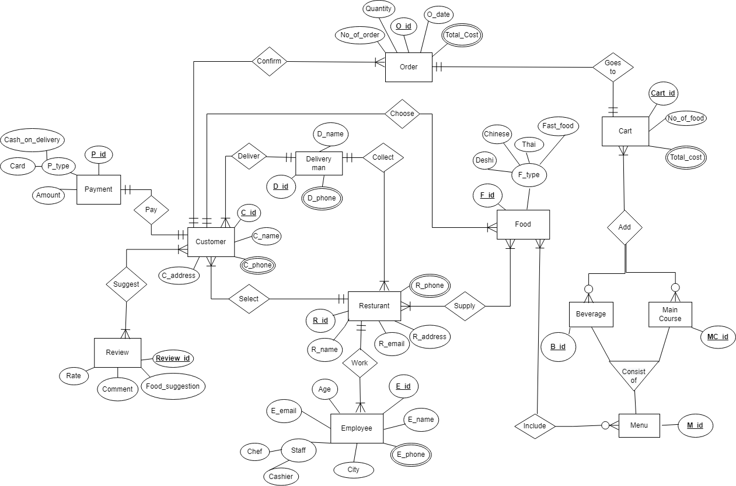

**NORMALIZATION:**

**DELIVERY MAN COLLECT RESTAURANT**

**UNF:**

COLLECT (R_ID, R_NAME, R_EMAIL, R_ADDRESS, D_ID, D_NAME, D_PHONE)

**1NF:**

D_PHONE, R_PHONE MULTIVALUED ATTRIBUTE.

**2NF:**

1. R_ID, R_NAME, R_EMAIL, R_ADDRESS, D_ID

2. D_ID, D_NAME, D_PHONE

**3NF:**

NO TRANSITIVE DEPENDENCY

1. R_ID, R_NAME, R_EMAIL, R_ADDRESS, D_ID

2. D_ID, D_NAME, D_PHONE

**TABLE:**

1. R_ID, R_NAME, R_EMAIL, R_ADDRESS, D_ID

2. D_ID, D_NAME, D_PHONE

**DELIVERY MAN DELIVER CUSTOMER**

**UNF:**

DELIVER (D_ID, D_NAME, D_PHONE, C_ID, C_NAME, C_PHONE, C_ADDRESS)

**1NF:**

C_PHONE, D_PHONE MULTIVALUED ATTRIBUTE.

**2NF:**

1.D_ID, D_NAME, D_PHONE

2.C_ID, C_NAME, C_ADDRESS, C_PHONE, D_ID

**3NF:**

NO TRANSITIVE DEPENDENCY

1.D_ID, D_NAME, D_PHONE

2.C_ID, C_NAME, C_ADDRESS, C_PHONE, D_ID

**TABLE:**

1.D_ID, D_NAME, D_PHONE

2.C_ID, C_NAME, C_ADDRESS, C_PHONE, D_ID

**CUSTOMER CONFIRM ORDER**

**UNF:**

CONFIRM (C_ID, C_NAME, C_PHONE, C_ADDRESS, O_ID,

O_DATE, QUANTITY, TOTAL COST, NO_OF_ORDER)

**1NF:**

C_PHONE MULTIVALUED ATTRIBUTE

**2NF:**

1. C_ID, C_NAME, C_PHONE, C_ADDRESS

2. O_ID, O_DATE, QUANTITY, TOTAL COST, NO_OF_ORDER

**3NF:**

1. C_ID, C_NAME, C_PHONE, C_ADDRESS

2. O_ID, O_DATE

3. QTN_ID, QUANTITY, TOTAL COST, NO_OF_ORDER

**TABLE:**

1. C_ID, C_NAME, C_PHONE, C_ADDRESS

2. O_ID, O_DATE

3. QTN_ID, QUANTITY, TOTAL COST, NO_OF_ORDER

**EMPLOYEE WORKS RESTURANT**

**UNF:**

WORKS (E_ID, E_NAME, E_EMAIL, E_CITY, E_PHONE, STAFF, CHEF, CASHIER, R_ID, R_NAME, R_EMAIL, R_CITY, R_PHONE)

**1NF:**

E_PHONE, R_PHONE MULTIVALUED ATTRIBUTE.

**2NF:**

1.E_ID, E_NAME, E_EMAIL, E_CITY, AGE, E_PHONE, STAFF, CHEF, CASHIER

2. R_ID, R_NAME, R_EMAIL, R_ADDRESS, R_PHONE.

**3NF:**

NO TRANSITIVE DEPENDENCY

1.E_ID, E_NAME, E_EMAIL, E_CITY, AGE, E_PHONE, STAFF, CHEF, CASHIER

2. R_ID, R_NAME, R_EMAIL, R_ADDRESS, R_PHONE.

**TABLE:**

1.E_ID, E_NAME, E_EMAIL, E_CITY, AGE, E_PHONE, STAFF, CHEF, CASHIER

2. R_ID, R_NAME, R_EMAIL, R_ADDRESS, R_PHONE.

**FOOD INCLUDE MENU**

**UNF:**

INCLUDE (F_ID, F_TYPE, DESHI, THAI, CHINESEE, FAST FOOD, M_ID)

**1NF:**

NO MULTIVALUED ATTRIBUTE

**2NF:**

1. F_ID, F_TYPE, DESHI, THAI, CHINESEE, FAST FOOD

2.M_ID

3.FM_ID, F_ID, M_ID

**3NF:**

NO TRANSITIVE DEPENDENCY

1. F_ID, F_TYPE, DESHI, THAI, CHINESEE, FAST FOOD

2. M_ID

3. FM_ID, F_ID, M_ID

**TABLE:**

1. F_ID, F_TYPE, DESHI, THAI, CHINESEE, FAST FOOD

2. M_ID

3. FM_ID, F_ID, M_ID

**CUSTOMER SUGGEST REVIEW**

**UNF:**

SUGGEST (C_ID, C_NAME, C_PHONE, C_ADDRESS, REVIEW_ID, FOOD_SUGGESTIONS, COMMENTS, RATE)

**1NF:**

C_PHONE MULTIVALUED ATTRIBUTE

**2NF:**

1.C_ID, C_NAME, C_PHONE, C_ADDRESS

2.REVIEW_ID, FOOD_SUGGESTIONS, COMMENTS, RATE

3.CRE_ID, C_ID, REVIEW_ID

**3NF:**

NO TRANSITIVE DEPENDENCY

1.C_ID, C_NAME, C_PHONE, C_ADDRESS

2.REVIEW_ID, FOOD_SUGGESTIONS, COMMENTS, RATE

3.CRE_ID, C_ID, REVIEW_ID

**TABLE:**

1.C_ID, C_NAME, C_PHONE, C_ADDRESS

2. REVIEW_ID, FOOD_SUGGESTIONS, COMMENTS, RATE

3.CRE_ID, C_ID, REVIEW_ID

**CUSTOMER PAY PAYMENT**

**UNF:**

PAY (C_ID, C_NAME, C_PHONE, C_ADDRESS, P_ID, AMOUNT, P_TYPE, CASH_ON_DELIVERY, CARD)

**1NF:**

C_PHONE MULTIVALUED ATTRIBUTE

**2NF:**

1. C_ID, C_NAME, C_PHONE, C_ADDRESS P_ID, AMOUNT, P_TYPE,

2. CASH_ON_DELIVERY, CARD CP_ID, P_ID, C_ID

**3NF:**

NO TRANSITIVE DEPENDENCY

1.C_ID, C_NAME, C_PHONE, C_ADDRESS

2.P_ID, AMOUNT, P_TYPE, CASH_ON_DELIVERY, CARD

3. CP_ID, P_ID, C_ID

**TABLE:**

1.C_ID, C_NAME, C_PHONE, C_ADDRESS

2. P_ID, AMOUNT, P_TYPE, CASH_ON_DELIVERY, CARD

3.CP_ID, P_ID, C_ID

**CUSTOMER SELECT RESTAURANT**

**UNF:**

SELECT (C_ID, C_NAME, C_PHONE, C_ADDRESS, R_ID, R_NAME, R_EMAIL, R_ADDRESS, R_PHONE)

**1NF:**

R_PHONE, C_PHONE MULTIVALUED ATTRIBUTE

**2NF:**

1.C_ID, C_NAME, C_PHONE, C_ADDRESS

2 R_ID,.R_NAME, R_EMAIL, R_ADDRESS, R_PHONE, C_ID

**3NF:**

NO TRANSITIVE DEPENDENCY

1.C_ID, C_NAME, C_PHONE, C_ADDRESS

2. R_ID, R_NAME, R_EMAIL, R_ADDRESS, R_PHONE, C_ID

**Table:**

1.C_ID, C_NAME, C_PHONE, C_ADDRESS

2. R_ID, R NAME, R_EMAIL, R_ADDRESS, R_PHONE, C_ID

**RESTAURANT SUPPLY FOOD**

SUPPLY (R_ID, R_NAME, R_EMAIL, R_ADDRESS, R_PHONE, F_ID,

F_TYPE, DESHI, THAI, CHINESEE, FAST FOOD)

**1NF:**

R_PHONE MULTIVALUED ATTRIBUTE

**2NF:**

1.R_ID, R_NAME, R_EMAIL, R_ADDRESS, R_PHONE F_ID,

2. F_TYPE, DESHI, THAI, CHINESEE, FAST FOOD) FR_ID, R_ID, F_ID

**3NF:**

NO TRANSITIVE DEPENDENCY

1.R_ID, R_NAME, R_EMAIL, R_ADDRESS, R_PHONE

2.F_ID, F_TYPE, DESHI, THAI, CHINESEE, FAST FOOD

3.FR_ID, R_ID, F_ID

**TABLE:**

1.R_ID, R_NAME, R_EMAIL, R_ADDRESS, R_PHONE

2.F_ID, F_TYPE, DESHI, THAI, CHINESEE, FAST FOOD

3.FR_ID, R_ID, F_ID

**MENU CONSIST OF BEVERAGE, MAIN COURSE**

**UNF:**

Consist of (M_ID, B_ID, MC_ID)

**1NF:**

NO MULTIVALUED ATTRIBUTE

**2NF:**

1.M_ID

2.B_ID

3.MC_ID

4.MM_ID, M_ID, B_ID

5.MMB_ID, M_ID, B_ID

**3NF:**

NO TRANSITIVE DEPENDENCY

1.M_ID

2.B_ID

3.MC_ID

4.MM_ID, M_ID, B_ID

5.MMB_ID, M_ID, B_ID

**TABLE:**

1.M_ID

2.B_ID

3.MC_ID

4.MB_ID, M_ID, B_ID

5.MM_ID, M_ID, B_ID

**BEVERAGE, MAIN COURSE ADD CART**

**UNF:**

ADD (B_ID, MC_ID, MC_ID, CART_ID, NO_OF_FOOD, TOTAL_COST)

**1NF:**

TOTAL COST MULTIVALUED ATTRIBUTE

**2NF:**

1.B_ID

2.MC_ID

3.CART_ID, NO_OF_FOOD, TOTAL_COST

**3NF:**

NO TRANSITIVE DEPENDENCY

1. B_ID

2.MC_ID

3.CART_ID, NO_OF_FOOD, TOTAL_COST

**TABLE:**

1. B_ID

2.MC_ID

3.CART_ID, NO_OF_FOOD, TOTAL_COST

**CART GOES TO ORDER**

**UNF:**

GOES TO (CART_ID, NO_OF_FOOD, TOTAL_COST, O_ID,

O_DATE, QUANTITY, TOTAL COST, NO_OF_ORDER)

**1NF:**

TOTAL_COST MULTIVALUED ATTRIBUTE

**2NF:**

1.CART_ID, NO_OF_FOOD, TOTAL_COST, O_ID

2.O_ID, O¬_DATE, QUANTITY, TOTAL COST, NO_OF_ORDER

**3NF:**

NO TRANSITIVE DEPENDENCY

1.CART_ID, NO_OF_FOOD, TOTAL_COST, O_ID

2.O_ID, O_DATE, QUANTITY, TOTAL COST, NO_OF_ORDER

**TABLE**:

1.CART ID, NO_OF_FOOD, TOTAL_COST, O_ID

2.O_ID, O_DATE, QUANTITY, TOTAL COST, NO_OF_ORDER

**CUSTOMER CHOOSE FOOD**

**UNF:**

CHOOSE (C_ID, C_NAME, C_PHONE, C_ADDRESS, F_ID, F_TYPE, DESHI, CHINESE, THAI, FAST_FOOD)

**1NF:**

C_PHONE MULTIVALUED ATTRIBUTE

**2NF:**

1. C_ID, C_NAME, C_PHONE, C_ADDRESS, F_ID

2. F_ID, F_TYPE, DESHI, CHINESE, THAI, FAST_FOOD

**3NF:**

NO TRANSITIVE DEPENDENCY

1.C_ID, C_NAME, C_PHONE, C_ADDRESS, F_ID

2.F_ID, F_TYPE, DESHI, CHINESE, THAI, FAST_FOOD

**TABLE:**

1.C_ID, C_NAME, C_PHONE, C_ADDRESS, F_ID

2.F_ID, F_TYPE, DESHI, CHINESE, THAI, FAST_FOOD

**TOTAL TABLE**

1.R_ID, R_NAME, R_EMAIL, R_ADDRESS, R_PHONE, D_ID

2. D_ID, D_NAME, D_PHONE

3.D_ID, D_NAME, D_PHONE

4.C_ID, C_NAME, C_PHONE, C_ADDRESS, D_ID

5.C_ID, C_NAME, C_PHONE, C_ADDRESS

6.O_ID, O_DATE

7.QTN_ID, QUANTITY, TOTAL COST, NO_OF_ORDER

8.E_ID, E_NAME, E_EMAIL, E_city,age,, E_PHONE, STAFF, CHEF,

CASHIER

9.R_ID, R_NAME, R_EMAIL, R_ADDRESS, R_PHONE

10.F_ID, F_TYPE, DESHI, THAI, CHINESEE, FAST FOOD

11. M_ID

12. FM_ID, F_ID, M_ID

13.C_ID, C_NAME, C_PHONE, C_ADDRESS

14. REVIEW_ID, FOOD_SUGGESTIONS, COMMENTS, RATE

15.CRE_ID, C_ID, REVIEW_ID

16.C_ID, C_NAME, C_PHONE, C_ADDRESS

17.P_ID, AMOUNT, P_TYPE, CASH_ON_DELIVERY, CARD

18.CP_ID, P_ID, C_ID

19.C_ID, C_NAME, C_PHONE, C_ADDRESS R_ID,

20.R_NAME, R_EMAIL, R_ADDRESS, R_PHONE, C_ID

21. R_ID, R_NAME, R_EMAIL, R_ADDRESS, R_PHONE

22.F_ID, F_TYPE, DESHI, THAI, CHINESEE, FAST FOOD

23.FR_ID, R_ID, F_ID

24.M_ID

25.B_ID

26.MC_ID

27. B_ID

28.MC_ID

29.MM_ID, M_ID, B_ID

30.MMB_ID, M_ID, B_ID

31.CART_ID, NO_OF_FOOD, TOTAL_COST

32.CART_ID, NO_OF_FOOD, TOTAL_COST, O_ID

33.O_ID, O_DATE, QUANTITY, TOTAL COST, NO_OF_ORDER

34. C_ID, C_NAME, C_PHONE, C_ADDRESS, F_ID

35. F_ID, F_TYPE, DESHI, CHINESE, THAI, FAST_FOOD

**FINAL TABLE**

|  |  |
| --- | --- |
| **serial** | **Table** |
| **1** | **R_ID**, R_NAME, R_EMAIL, R_ADDRESS, R_PHONE, D_ID |
| **2** | **D_ID**, D_NAME, D_PHONE |
| **3** | **C_ID**, C_NAME, C_PHONE, C_ADDRESS, D_ID |
| 4 | **QNT_ID**, QUANTITY, TOTAL COST, NO_OF_ORDER |
| 5 | **E_ID**, E_NAME, E_EMAIL, E_CITY, AGE, E_PHONE, STAFF, CHEF, CASHIER |
| 6 | **F_ID**, F_TYPE, DESHI, THAI, CHINESEE, FAST FOOD |
| 7 | **M_ID** |
| 8 | **FM_ID**, F_ID, M_ID |
| 9 | **REVIEW_ID**, FOOD_SUGGESTIONS, COMMENTS, RATE |
| **10** | **P_ID**, AMOUNT, P_TYPE, CASH_ON_DELIVERY, CARD |
| **11** | **R_ID**, R_NAME, R_EMAIL, R_ADDRESS, R_PHONE, C_ID |
| **12** | **FR_ID**, R_ID, F_ID |
| **13** | **B_ID** |
| **14** | **MC_ID** |
| **15** | **MMB_ID**, M_ID, B_ID |
| **16** | **MM_ID**, MC_ID, B_ID |
| **17** | **CART_ID**, NO_OF_FOOD, TOTAL_COST, O_ID |
| 18 | **O_ID**, O_DATE, QUANTITY, TOTAL COST, NO_OF_ORDER |
| 19 | **C_ID**, C_NAME, C_PHONE, C_ADDRESS, F_ID |

**TABLE CREATION**

**TABLE:** **DELIVERY_MAN**

|  |
| --- |
| CREATE TABLE DELIVERY_MAN  (  D_ID NUMBER (20) CONSTRAINT D_ID_PK PRIMARY KEY,  D_NAME VARCHAR2(20) NOT NULL,  D_PHONE NUMBER (11) NOT NULL  );  DESC DELIVERY_MAN |

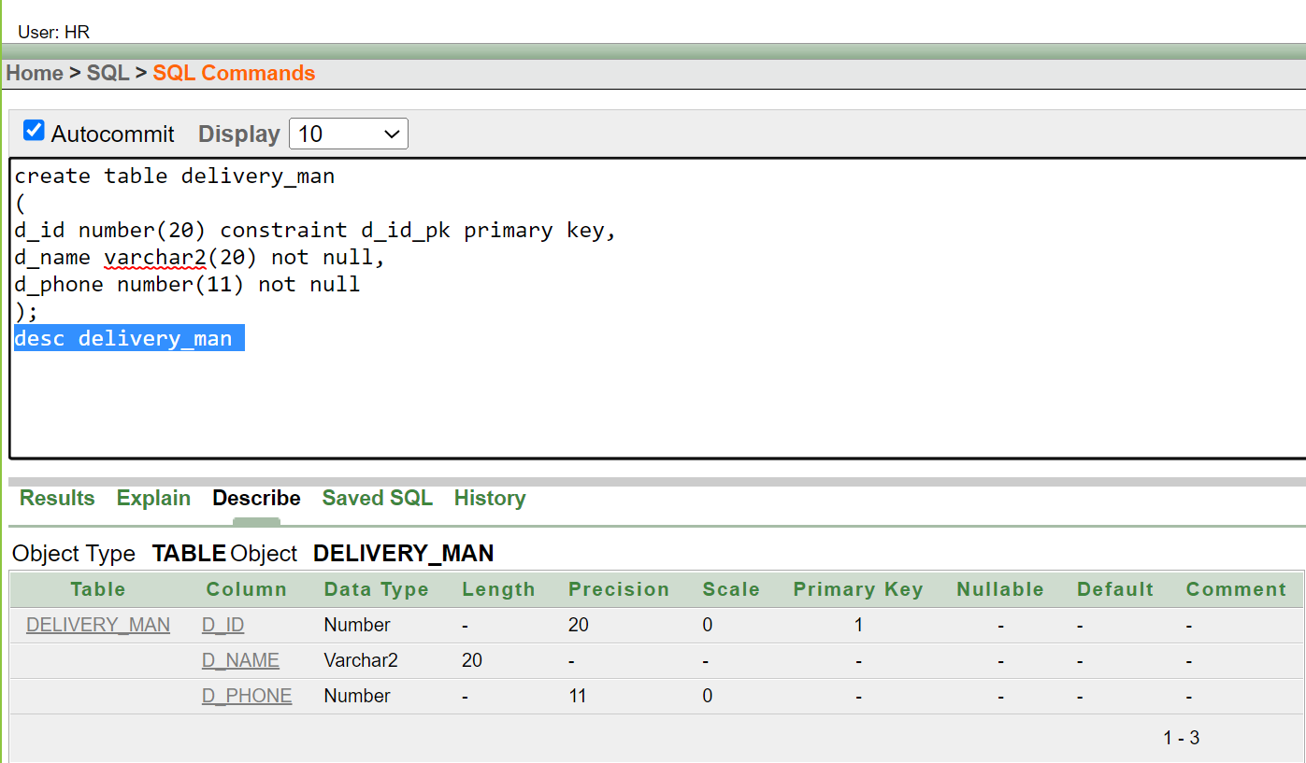

**TABLE: RESTURANT 1**

|  |
| --- |
| CREATE TABLE RESTURANT1  (  R_ID NUMBER (20) CONSTRAINT R_ID_PK PRIMARY KEY,  R_NAME VARCHAR2(20) NOT NULL,  R_EMAIL VARCHAR2(30) UNIQUE,  R_ADDRESS VARCHAR2(50),  R_PHONE NUMBER (10) NOT NULL,  D_ID NUMBER (10) CONSTRAINT RES_DEL_FK REFERENCES DELIVERY_MAN (D_ID)  );  DESC RESTURANT1 |

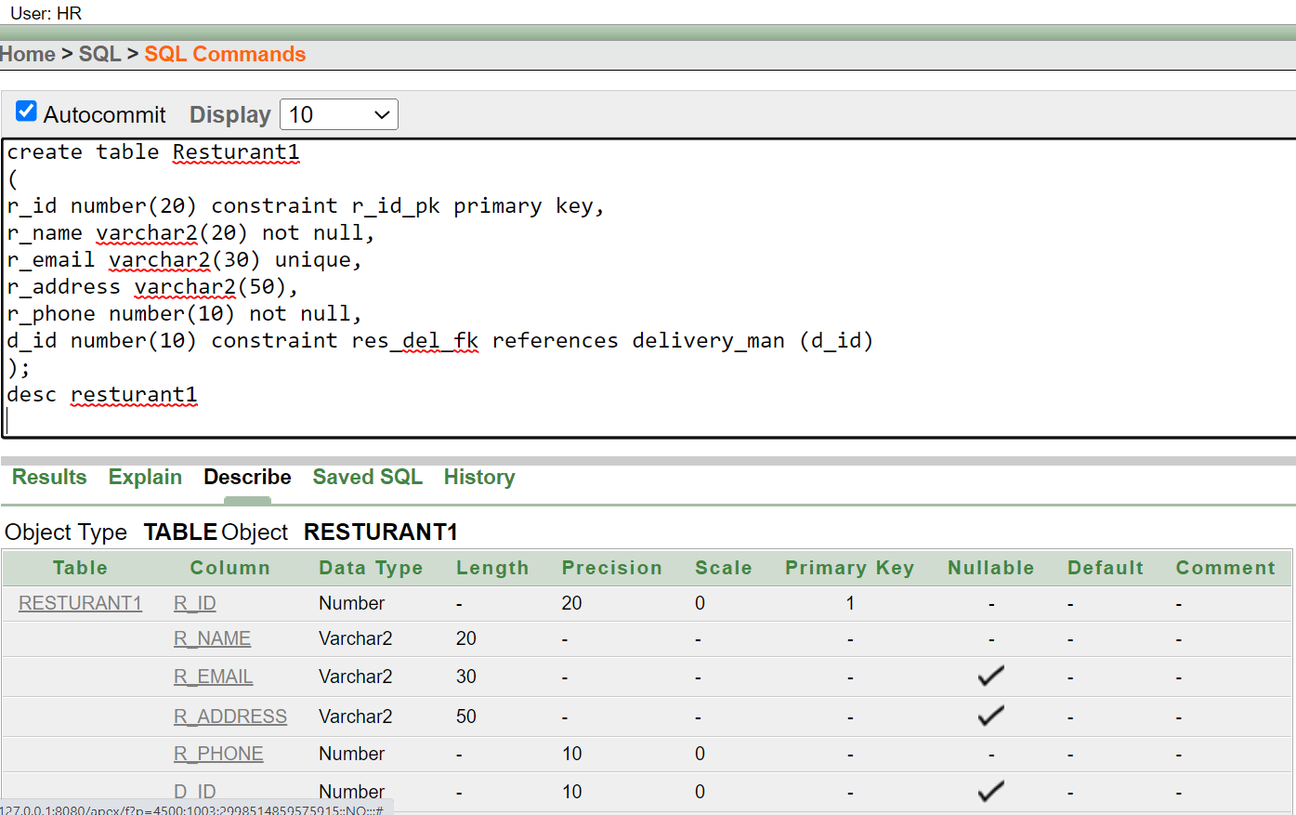

**TABLE: CUSTOMER 1**

|  |
| --- |
| CREATE TABLE CUSTOMER1  (  C_ID NUMBER (20) CONSTRAINT C_ID_PK PRIMARY KEY,  C_NAME VARCHAR2(20) NOT NULL,  C_ADDRESS VARCHAR2(50),  C_PHONE NUMBER (10) NOT NULL,  D_ID NUMBER (10) CONSTRAINT CUSTOMER_ID_FK REFERENCES DELIVERY_MAN (D_ID)  );  DESC CUSTOMER1 |

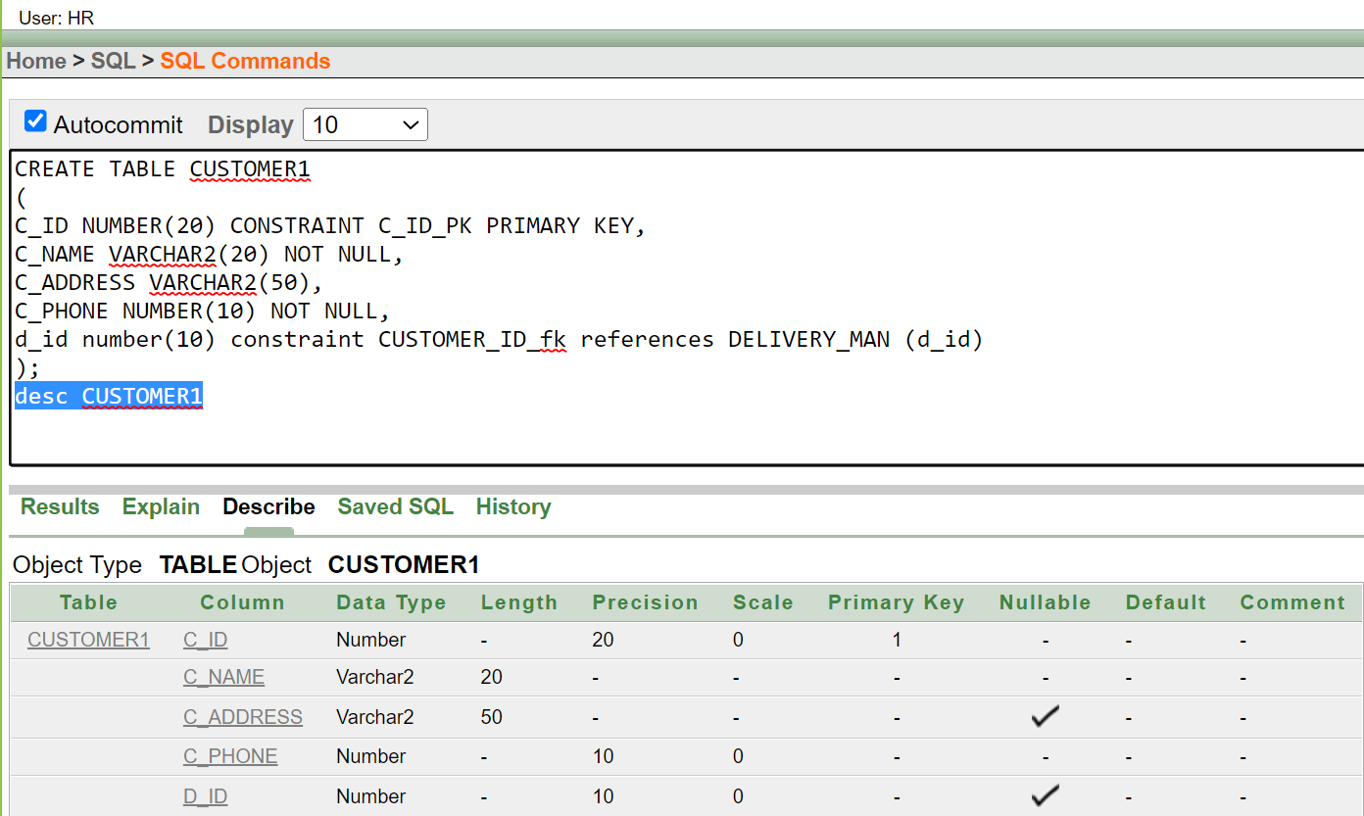

**TABLE: QNT**

|  |
| --- |
| CREATE TABLE QNT (  QNT_ID NUMBER (20) CONSTRAINT QNT_ID_PK PRIMARY KEY,  QUANTITY NUMBER (20) NOT NULL,  TOTAL_COST NUMBER (10),  NO_OF_ORDER NUMBER (10)  )  DESC QTN |

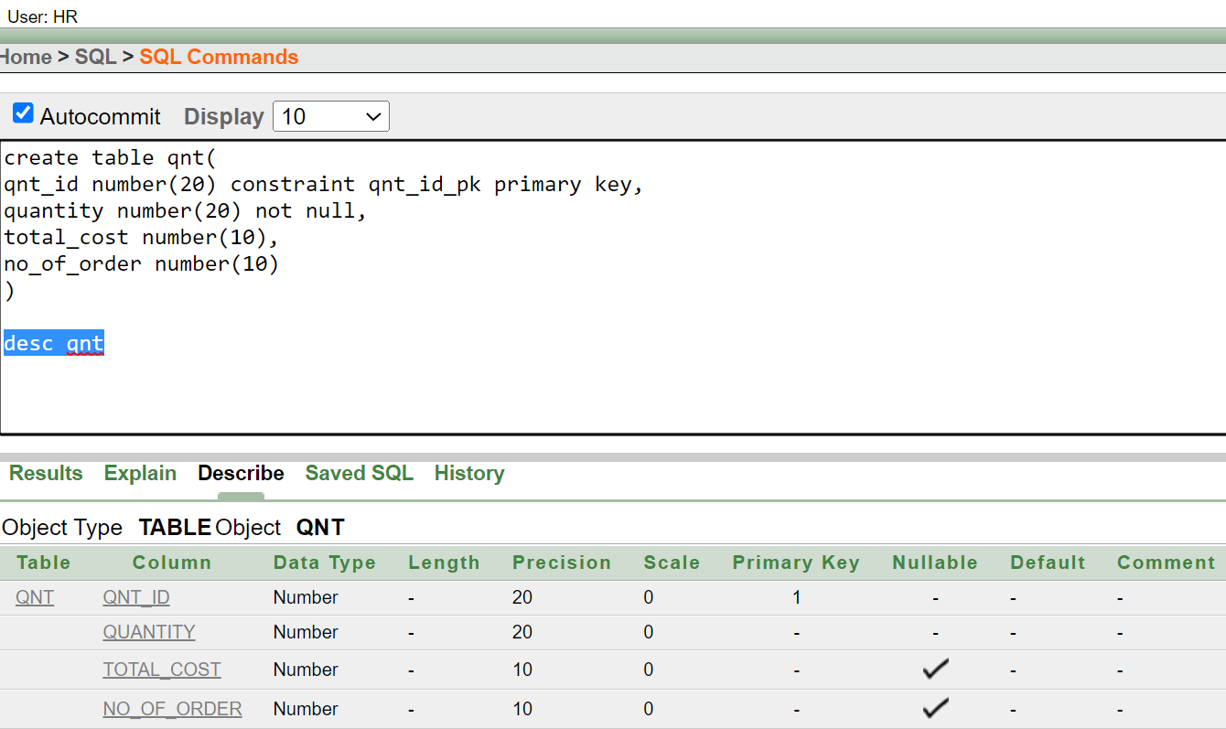

**TABLE: EMPLOYEE**

|  |
| --- |
| CREATE TABLE EMPLOYEE  (  E_ID NUMBER (20) CONSTRAINT E_ID_PK PRIMARY KEY,  E_NAME VARCHAR2(20) NOT NULL,  E_EMAIL VARCHAR2(30) UNIQUE,  E_CITY VARCHAR2(50) DEFAULT 'UTTARA',  E_PHONE NUMBER (10) NOT NULL,  AGE NUMBER (2) CHECK(AGE>=18),  CHEF VARCHAR2(50),  CASHIER VARCHAR2(50),  STAFF VARCHAR2(50),  WAITER VARCHAR2(50),  CLEANER VARCHAR2(50)  )  DESC EMPLOYEE |
|  |

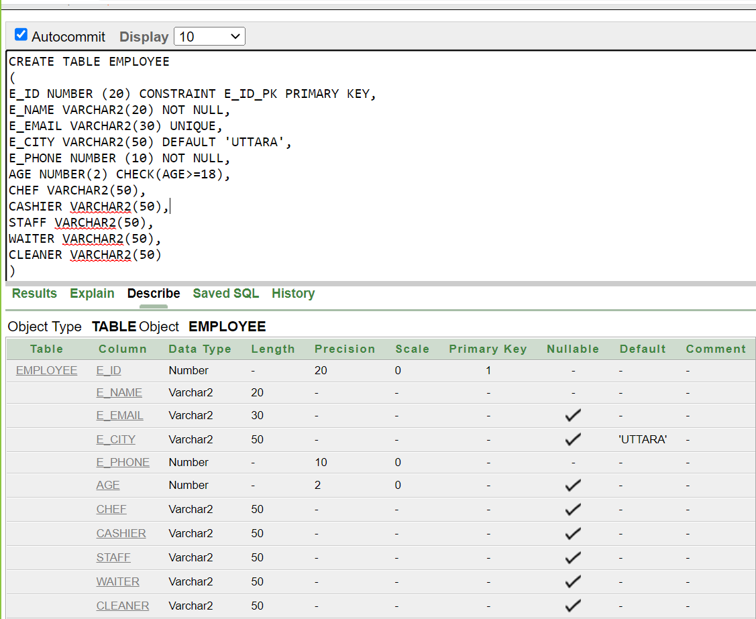

**TABLE: FOOD**

|  |
| --- |
| CREATE TABLE FOOD (  F_ID NUMBER (20) CONSTRAINT F_ID_PK PRIMARY KEY,  DESHI VARCHAR2(20),  THAI VARCHAR2(30),  CHINESE VARCHAR2(50),  FAST_FOOD VARCHAR2(50)  )  DESC FOOD |

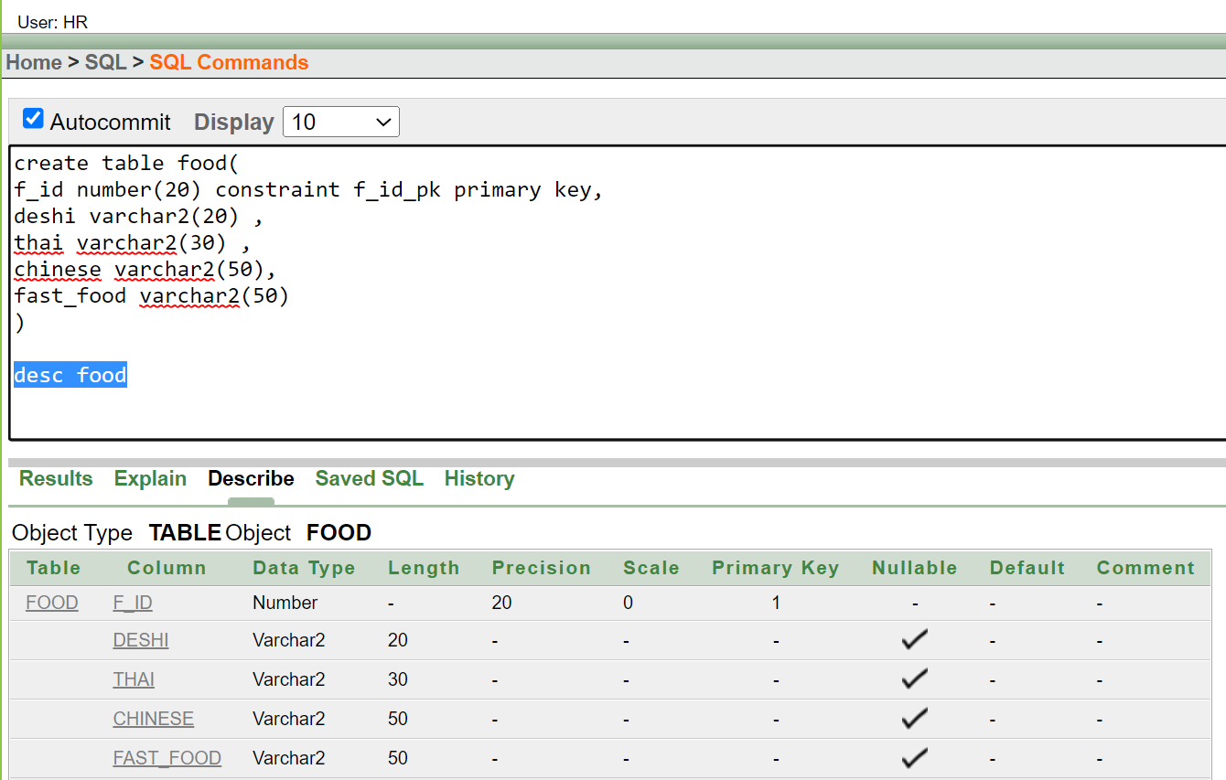

**TABLE: MENU**

|  |
| --- |
| CREATE TABLE MENU  (  M_ID NUMBER (20) CONSTRAINT M_ID_PK PRIMARY KEY  )  DESC MENU |

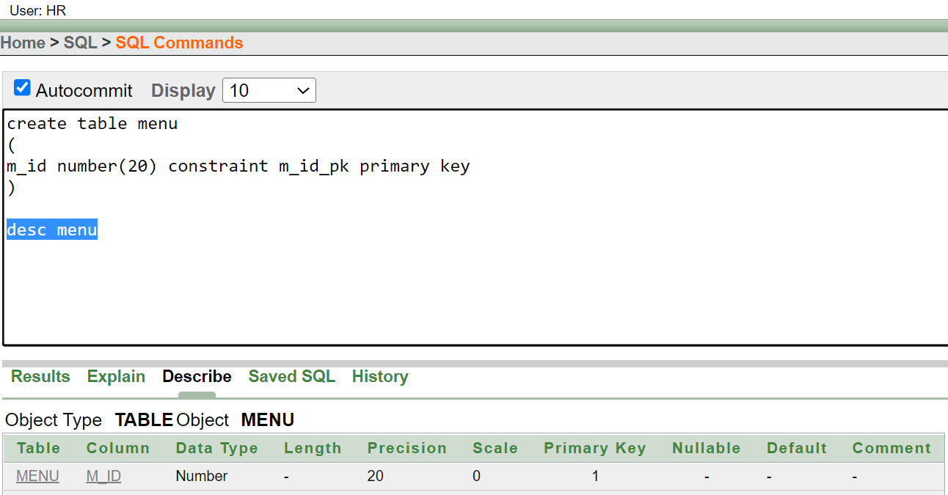

**TABLE: FM**

|  |
| --- |
| CREATE TABLE FM  (  FM_ID NUMBER (10) CONSTRAINT FM_ID_PK PRIMARY KEY  F_ID NUMBER (10) CONSTRAINT F_M_FK REFERENCES FOOD (F_ID),  M_ID NUMBER (10) CONSTRAINT FM_FK REFERENCES MENU (M_ID)  )  DESC FM |

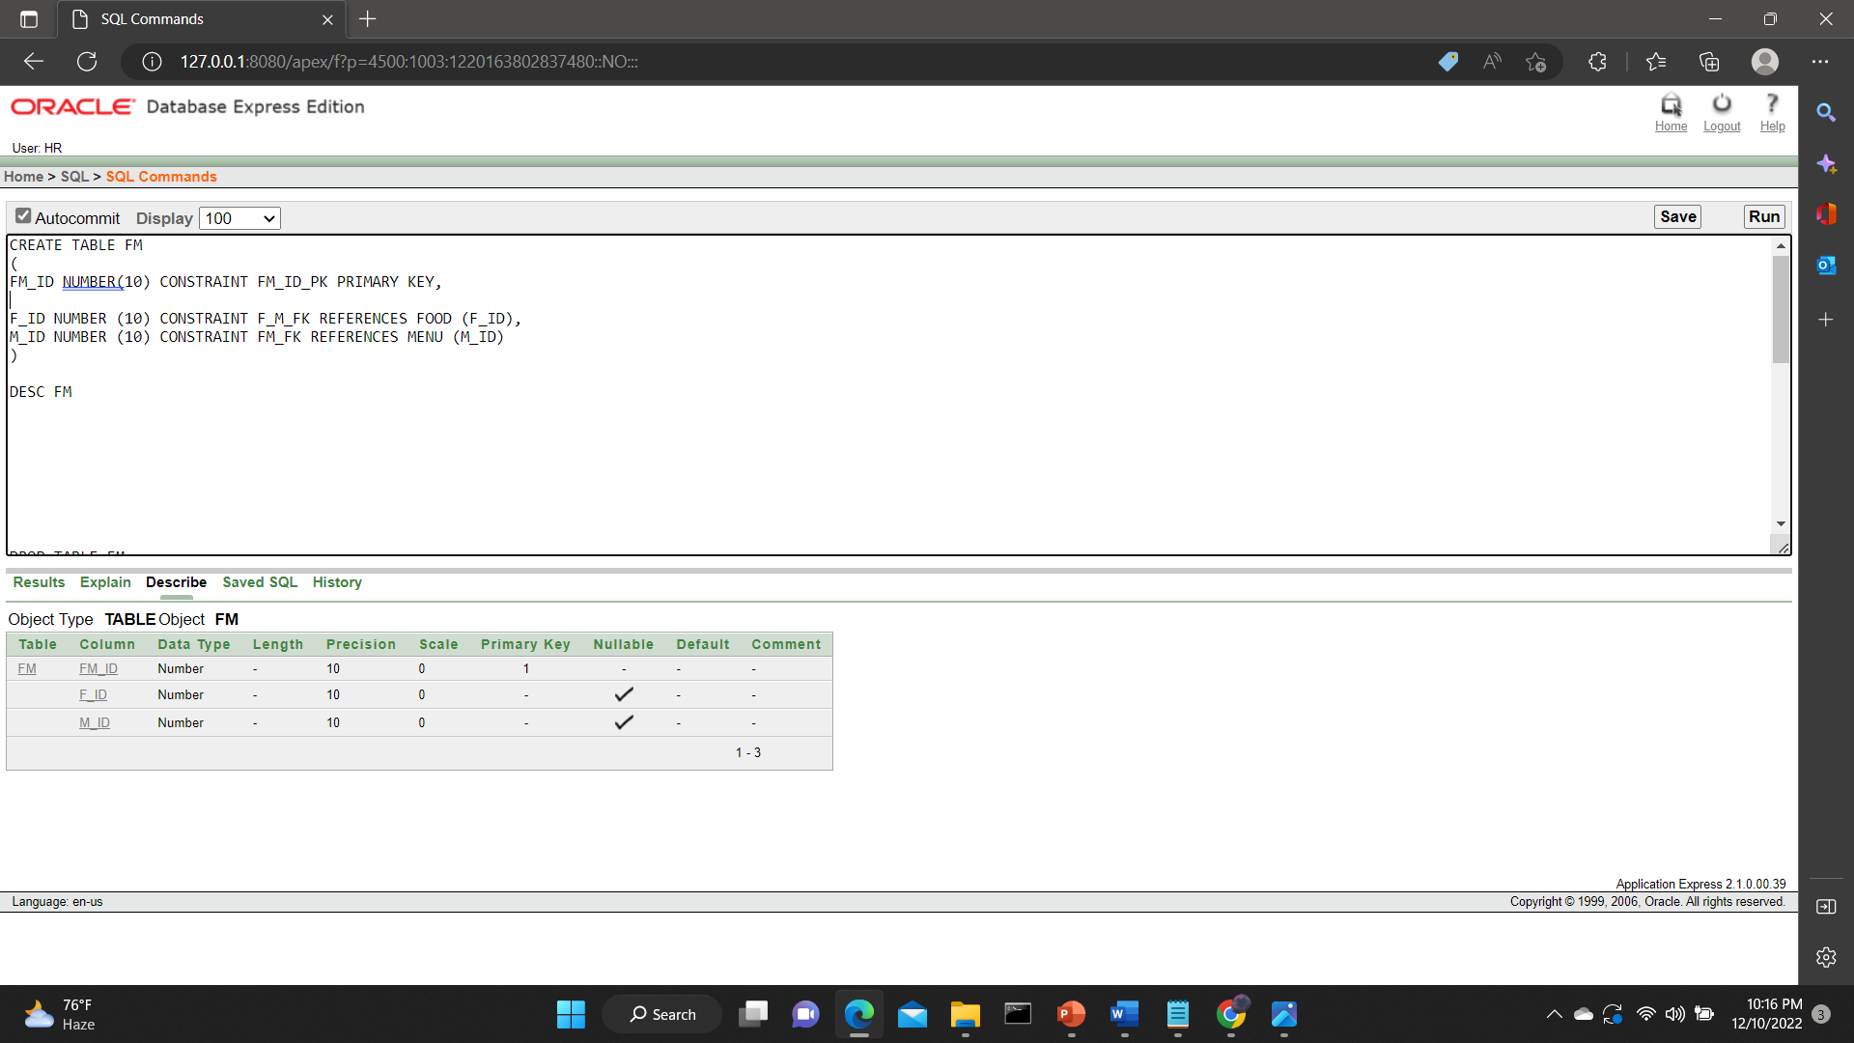

**TABLE: REVIEW1**

|  |
| --- |
| CREATE TABLE REVIEW1  (  REVIEW1_ID NUMBER (4) CONSTRAINT REVIEW1_ID_PK PRIMARY KEY,  FOOD VARCHAR2(20) NOT NULL,  SUGGESTIONS VARCHAR2(50),  COMMENTS VARCHAR2(100),  RATE NUMBER (1)  );  DESC REVIEW1 |

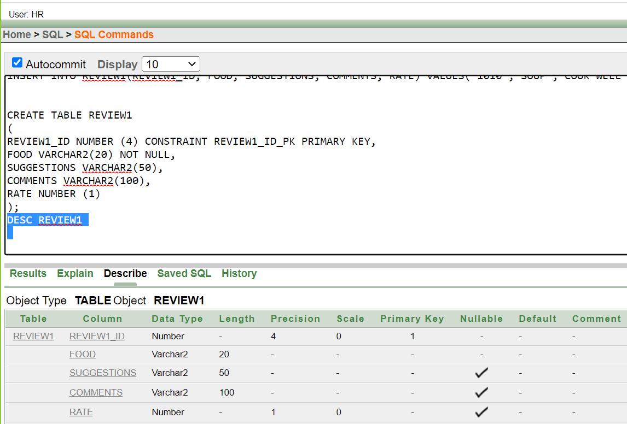

**TABLE: CREID**

|  |
| --- |
| CREATE TABLE CREID  (  CRE_ID NUMBER (10) CONSTRAINT CRE_ID_PK PRIMARY KEY,  C_ID NUMBER (10) CONSTRAINT C_R_FK REFERENCES CUSTOMER1(C_ID),  REVIEW_ID NUMBER (10) CONSTRAINT CE_FK REFERENCES REVIEW (REVIEW_ID)  )  DESC CREID |

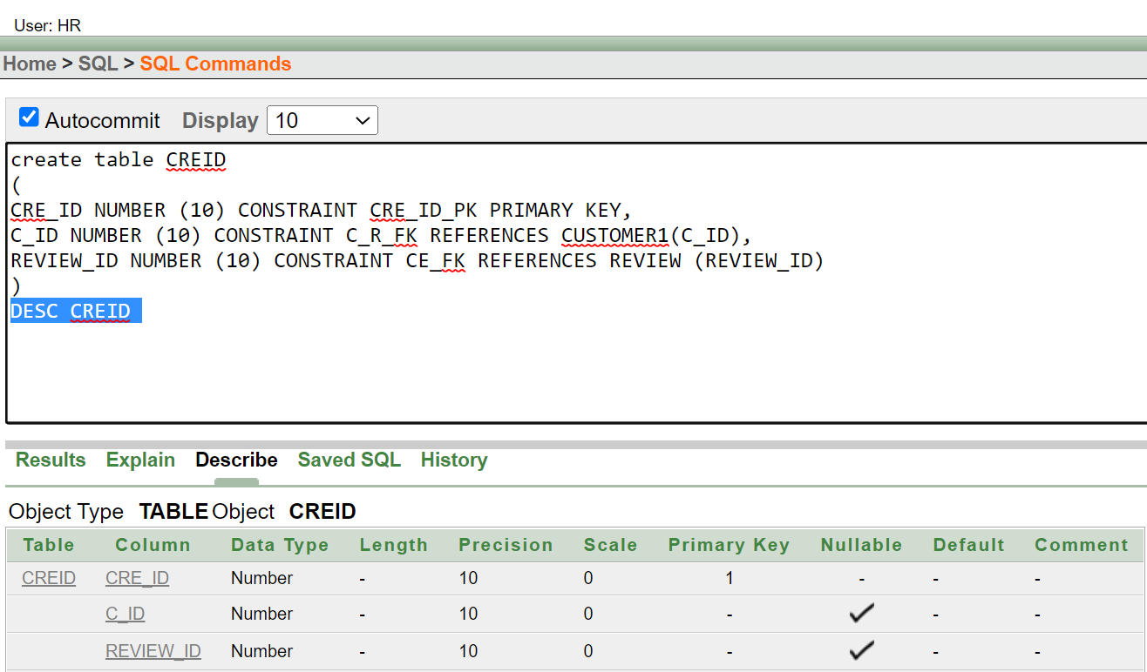

**TABLE: PAYMENT1**

|  |
| --- |
| CREATE TABLE PAYMENT1  (  P_ID NUMBER (10) CONSTRAINT PAY_ID_PK PRIMARY KEY,  AMOUNT NUMBER (10) NOT NULL,  P_TYPE VARCHAR2(15),  CASH_ON_DELIVERY VARCHAR (10),  CARD VARCHAR (10)  )  DESC PAYMENT1 |

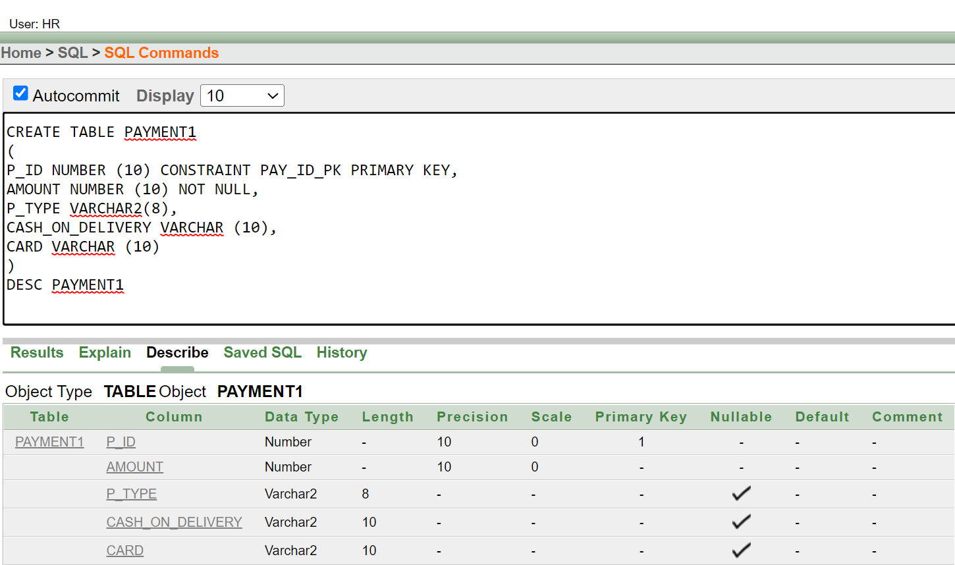

**TABLE: CPID**

|  |
| --- |
| CREATE TABLE CPID  (  CP_ID NUMBER (10) CONSTRAINT CP_ID_PK PRIMARY KEY,  P_ID NUMBER (10) CONSTRAINT C_P_FK REFERENCES PAYMENT (P_ID),  C_ID NUMBER (10) CONSTRAINT CP_FK REFERENCES CUSTOMER1(C_ID)  );  DESC CPID |

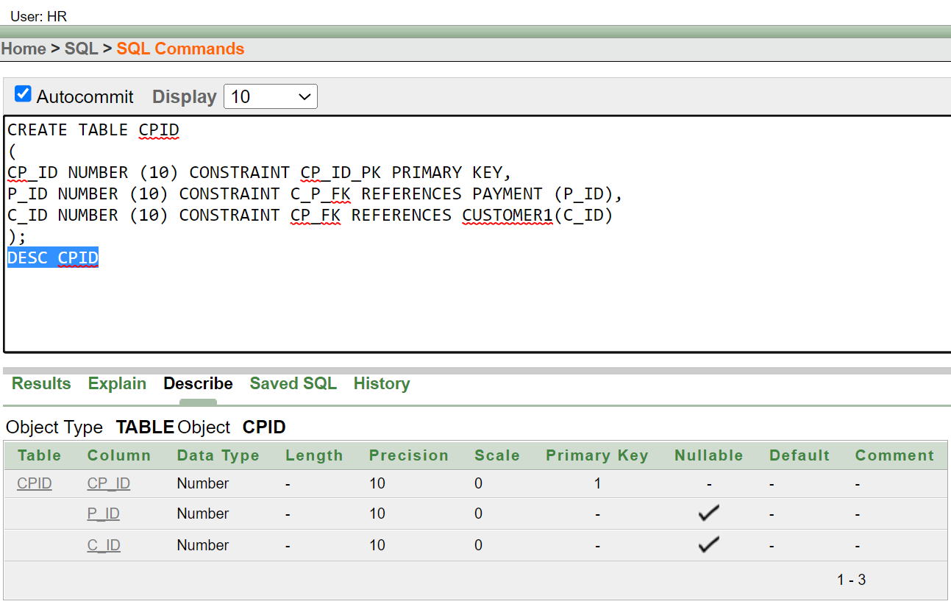

**TABLE: RESTAURANT 2**

|  |
| --- |
| CREATE TABLE RESTURANT2  (  R_ID NUMBER (10) CONSTRAINT RES_ID_PK PRIMARY KEY,  R_NAME VARCHAR2(40) NOT NULL,  R_EMAIL VARCHAR2(20) UNIQUE,  R_ADDRESS VARCHAR2(50),  R_PHONE NUMBER (15) NOT NULL,  C_ID NUMBER (13) CONSTRAINT CUS_RES_FK REFERENCES CUSTOMER1(C_ID)  );  DESC RESTURANT2 |

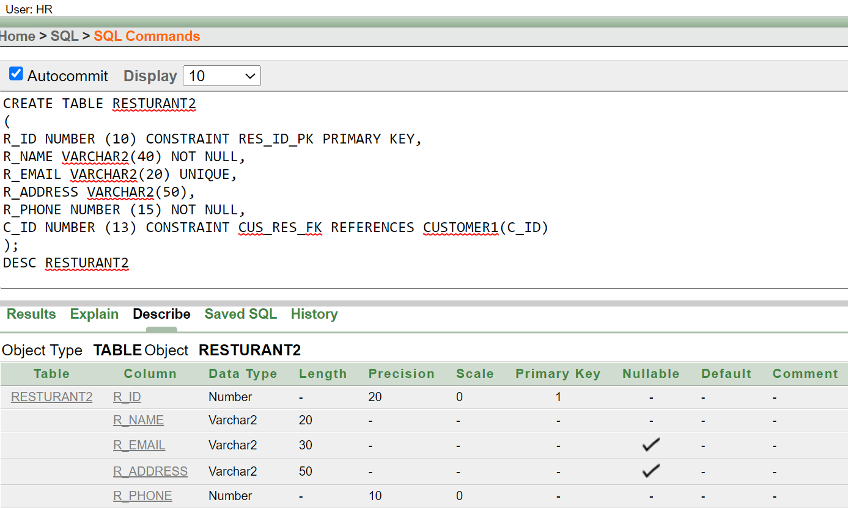

**TABLE: FR**

|  |
| --- |
| CREATE TABLE FR  (  FR_ID NUMBER(11) CONSTRAINT FR_PK PRIMARY KEY,  F_ID NUMBER (10) CONSTRAINT F_R_FK REFERENCES FOOD (F_ID),  R_ID NUMBER (10) CONSTRAINT FR_FK REFERENCES RESTURANT1 (R_ID)  )  DESC FR |

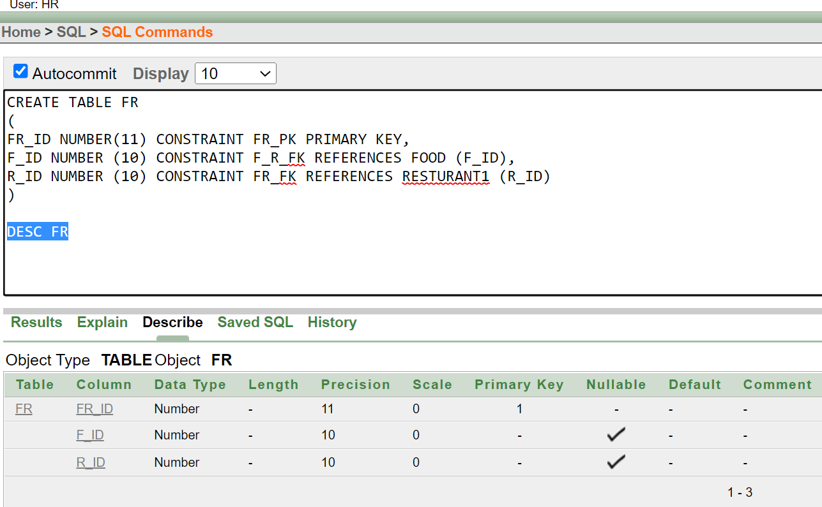

**TABLE: BEVERAGE**

|  |
| --- |
| CREATE TABLE BEVERAGE  (  B_ID NUMBER (11) CONSTRAINT B_PK PRIMARY KEY  )  DESC BEVERAGE |

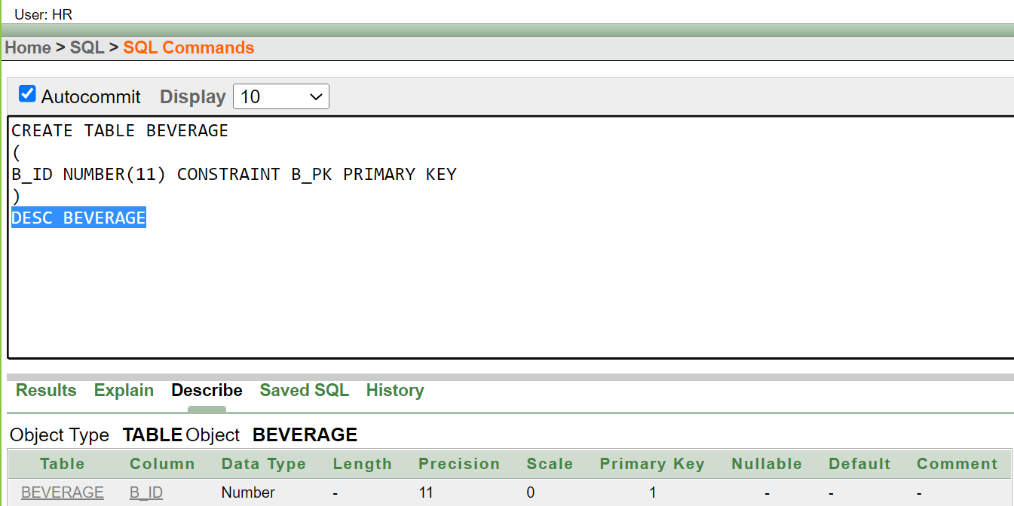

**TABLE: MAIN COURSE**

|  |
| --- |
| CREATE TABLE MAIN_COURSE  (  MC_ID NUMBER (11) CONSTRAINT MC_PK PRIMARY KEY  )  DESC MAIN_COURSE |

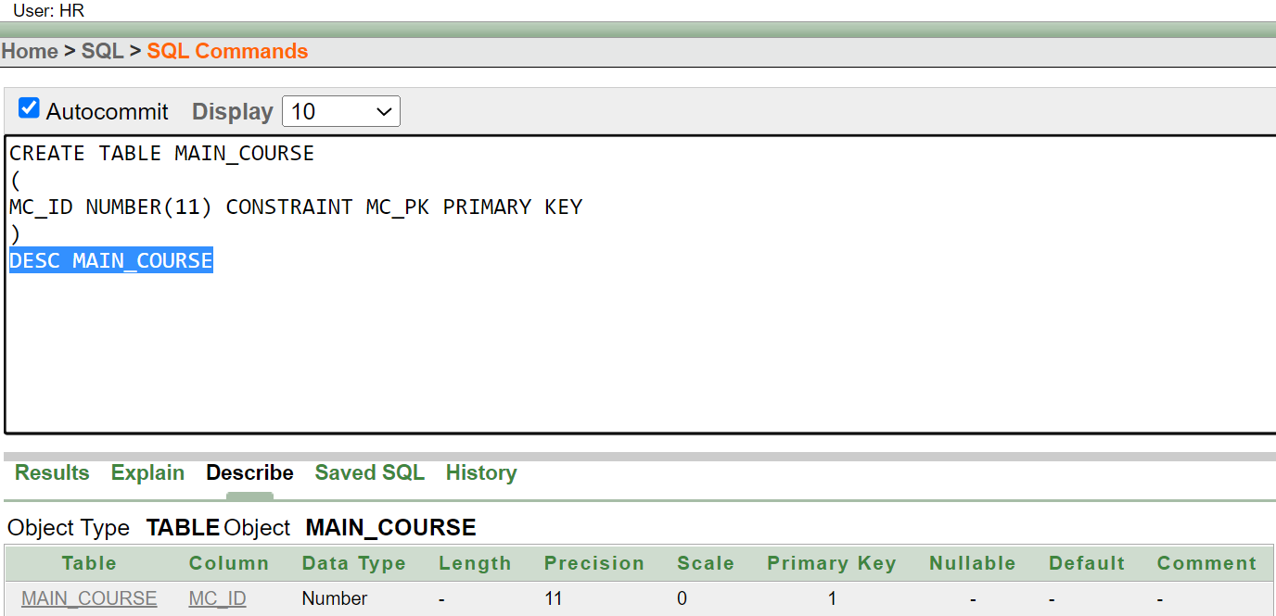

**TABLE: MMB**

|  |
| --- |
| CREATE TABLE MMB  (  MMB_ID NUMBER(15) CONSTRAINT MMB_PK PRIMARY KEY,  B_ID NUMBER (10) CONSTRAINT MB_MB_FK REFERENCES BEVERAGE(B_ID),  M_ID NUMBER (10) CONSTRAINT MM1_FK REFERENCES MENU (M_ID)  )  DESC MMB |

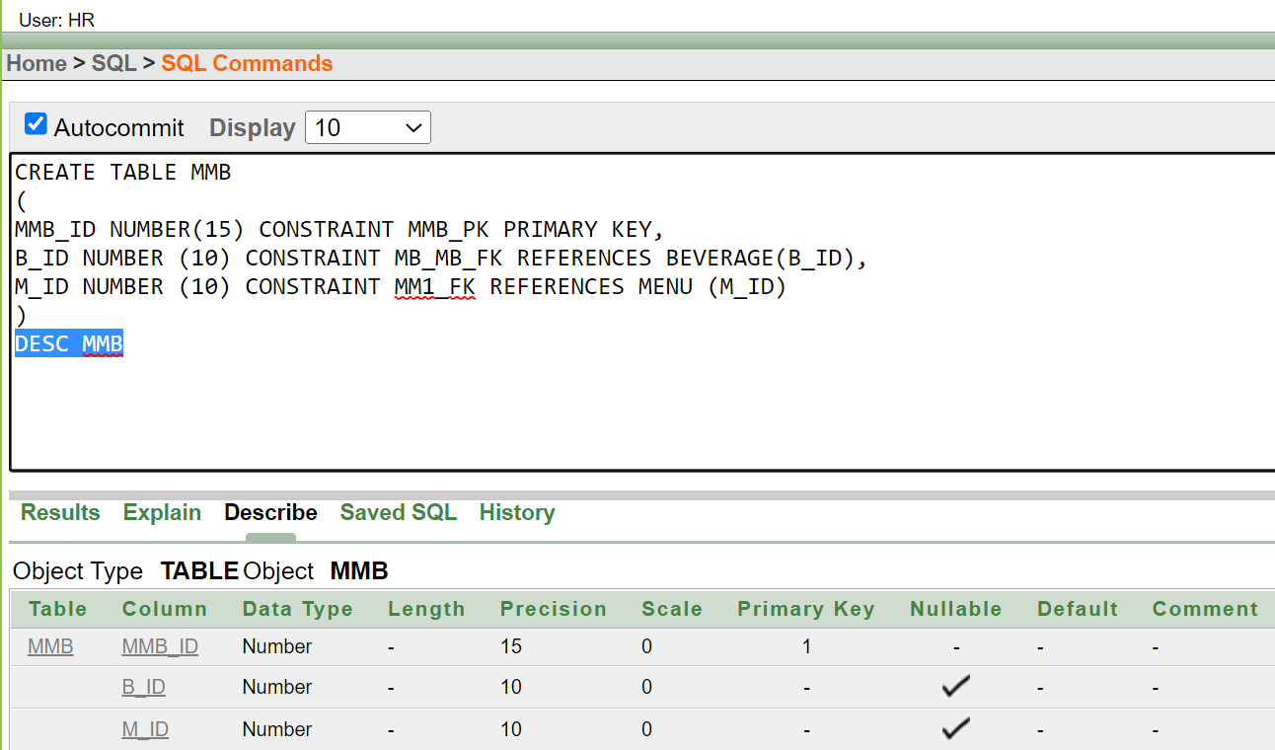

**TABLE: MMC**

|  |
| --- |
| CREATE TABLE MMC  (  MMC_ID NUMBER (15) CONSTRAINT MB_PK PRIMARY KEY,  MC_ID NUMBER (10) CONSTRAINT MC_B_FK REFERENCES MAIN_COURSE,  M_ID NUMBER (10) CONSTRAINT M_FK REFERENCES MENU (M_ID)  )  DESC MMC |

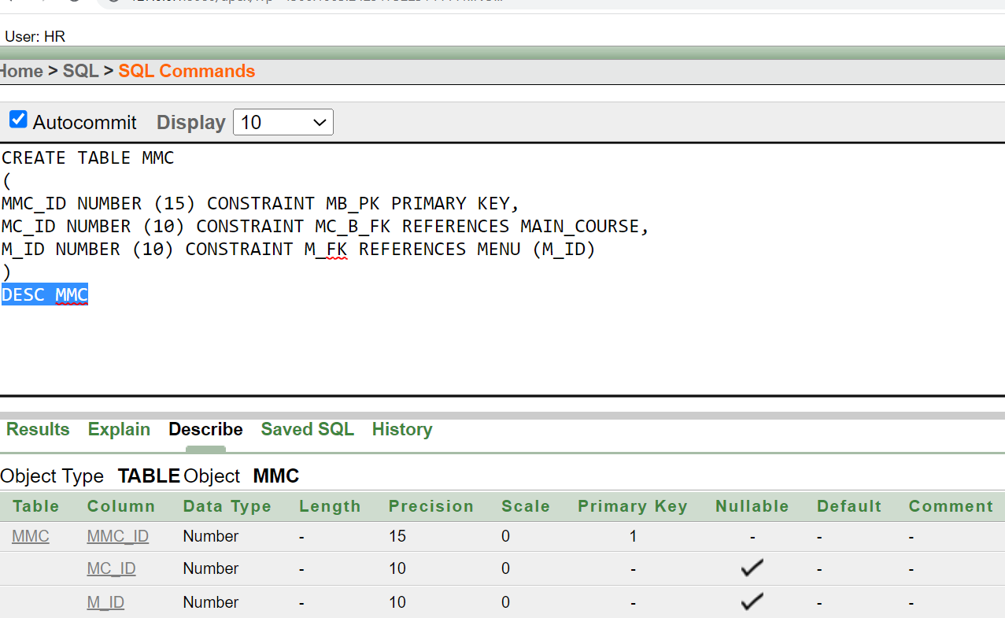

**TABLE: CART**

|  |
| --- |
| CREATE TABLE CART  (  CART_ID NUMBER (15) CONSTRAINT CART_PK PRIMARY KEY,  NO_OF_FOOD NUMBER (10) NOT NULL,  TOTAL_COST NUMBER (15) NOT NULL,  O_ID NUMBER (10) CONSTRAINT O_FK REFERENCES ORD (O_ID)  )  DESC CART |

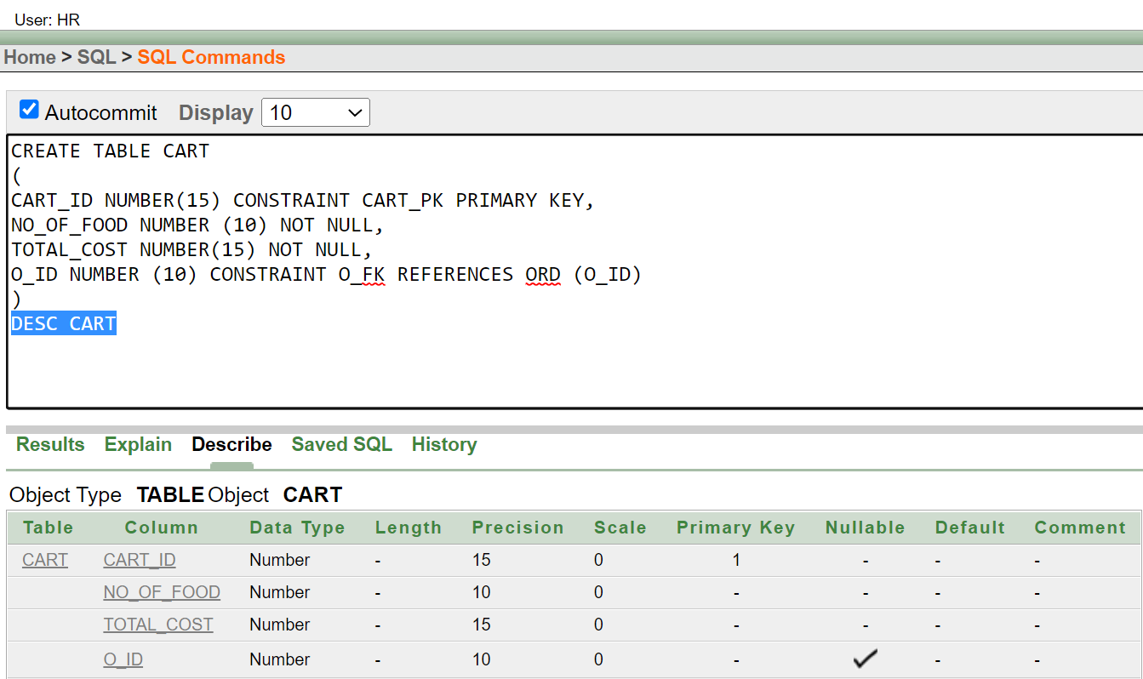

**TABLE: ORDER**

|  |
| --- |
| CREATE TABLE ORD  (  O_ID NUMBER(15) CONSTRAINT O_PK PRIMARY KEY,  O_DATE date,  QUANTITY VARCHAR2(20),  TOTAL_COST NUMBER(15) NOT NULL,  NO_OF_ORDER NUMBER(20) NOT NULL  );desc ORD |

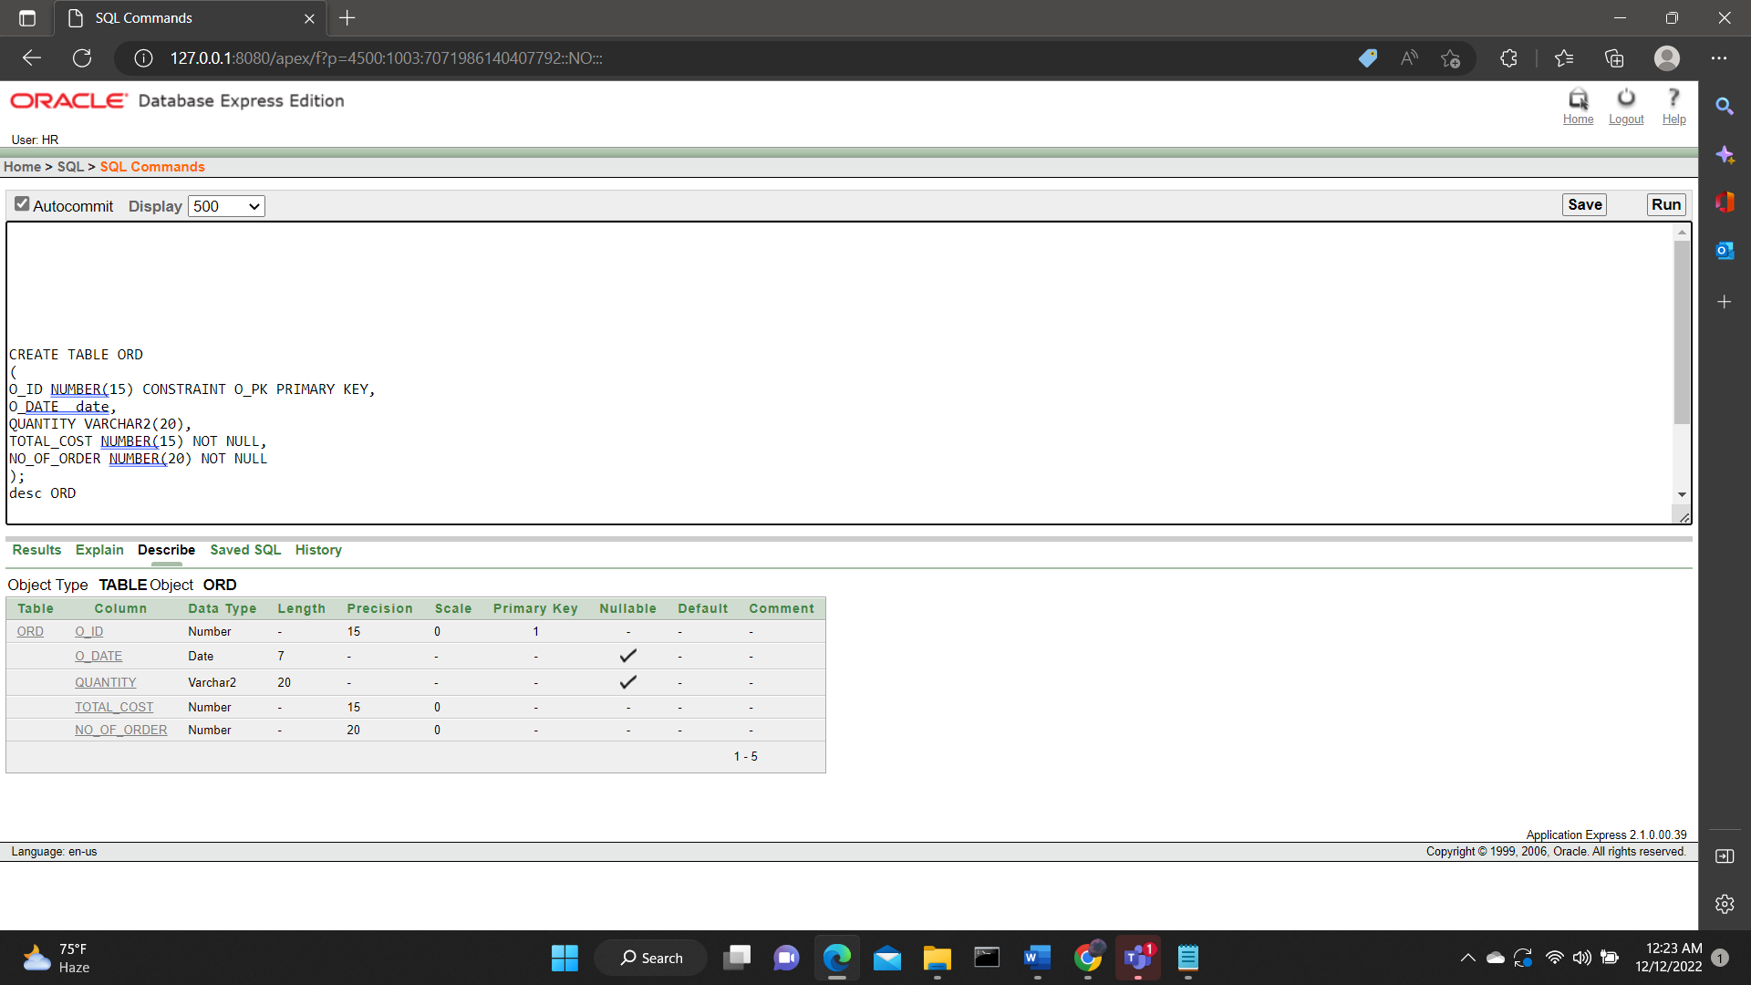

**TABLE: CUSTOMER2**

|  |
| --- |
| CREATE TABLE CUSTOMER2  (  C_ID NUMBER (20) CONSTRAINT C_ID_PK PRIMARY KEY,  C_NAME VARCHAR2(20) NOT NULL,  C_ADDRESS VARCHAR2(50),  C_PHONE NUMBER (10) NOT NULL,  F_ID NUMBER (10) CONSTRAINT FOOD_ID_FK REFERENCES FOOD (D_ID)  );  DESC CUSTOMER2 |

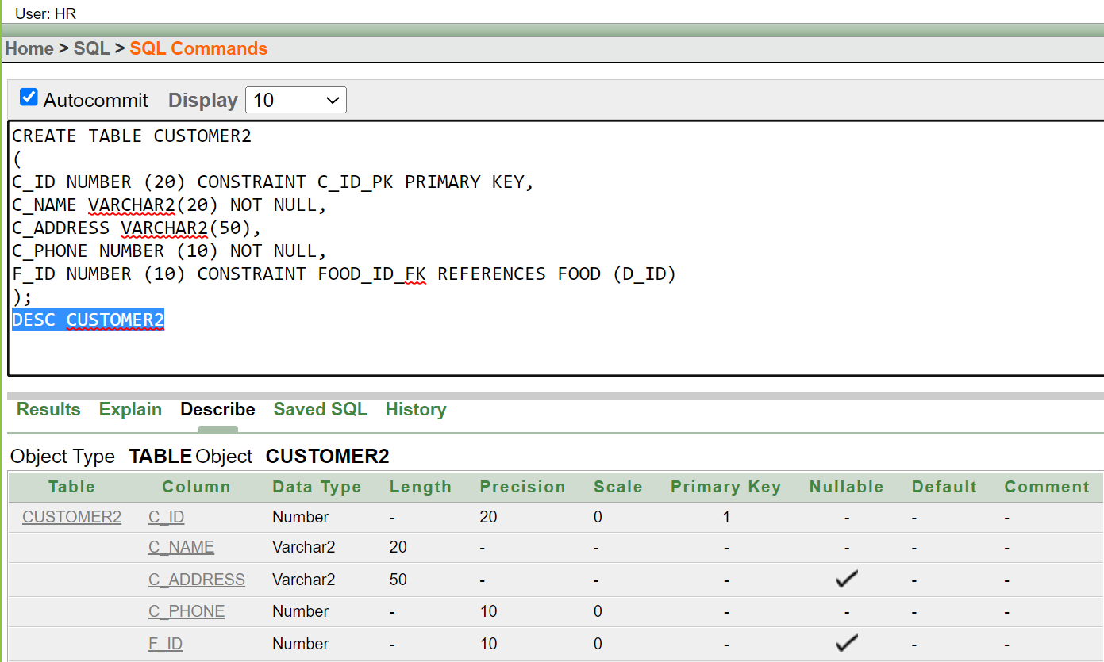

**DATA INSERTION AND SEQUENCE:**

**1.FOOD:**

|  |
| --- |
| CREATE SEQUENCE F_F_ID INCREMENT BY 1 START WITH 901 MAXVALUE 960  NOCACHE NOCYCLE  SELECT * FROM FOOD  INSERT INTO FOOD (F_ID, DESHI, THAI, CHINESE, FAST_FOOD) VALUES (F_F_ID.NEXTVAL, 'KACCHI BIRYANI', NULL, NULL, NULL)  INSERT INTO FOOD (F_ID, DESHI, THAI, CHINESE, FAST_FOOD) VALUES (F_F_ID.NEXTVAL, NULL, NULL, NULL, 'BURGER')  INSERT INTO FOOD (F_ID, DESHI, THAI, CHINESE, FAST_FOOD) VALUES (F_F_ID.NEXTVAL, 'BHUNA KHICHURI', NULL, NULL, NULL)  INSERT INTO FOOD (F_ID, DESHI, THAI, CHINESE, FAST_FOOD) VALUES (F_F_ID.NEXTVAL, NULL, NULL, NULL, 'PASTA')  INSERT INTO FOOD (F_ID, DESHI, THAI, CHINESE, FAST_FOOD) VALUES (F_F_ID.NEXTVAL, NULL, 'CRISPY THAI CHICKEN', NULL, NULL)  INSERT INTO FOOD (F_ID, DESHI, THAI, CHINESE, FAST_FOOD) VALUES (F_F_ID.NEXTVAL, NULL, NULL, 'STEAMED BUN', NULL)  INSERT INTO FOOD (F_ID, DESHI, THAI, CHINESE, FAST_FOOD) VALUES (F_F_ID.NEXTVAL, NULL, 'FISH CAKE', NULL, NULL)  INSERT INTO FOOD (F_ID, DESHI, THAI, CHINESE, FAST_FOOD) VALUES (F_F_ID.NEXTVAL, NULL, NULL,'MOMO', NULL)  INSERT INTO FOOD (F_ID, DESHI, THAI, CHINESE, FAST_FOOD) VALUES (F_F_ID.NEXTVAL, 'KALA BHUNA', NULL, NULL, NULL)  INSERT INTO FOOD (F_ID, DESHI, THAI, CHINESE, FAST_FOOD) VALUES (F_F_ID.NEXTVAL, NULL, NULL, NULL, 'PIZZA') |

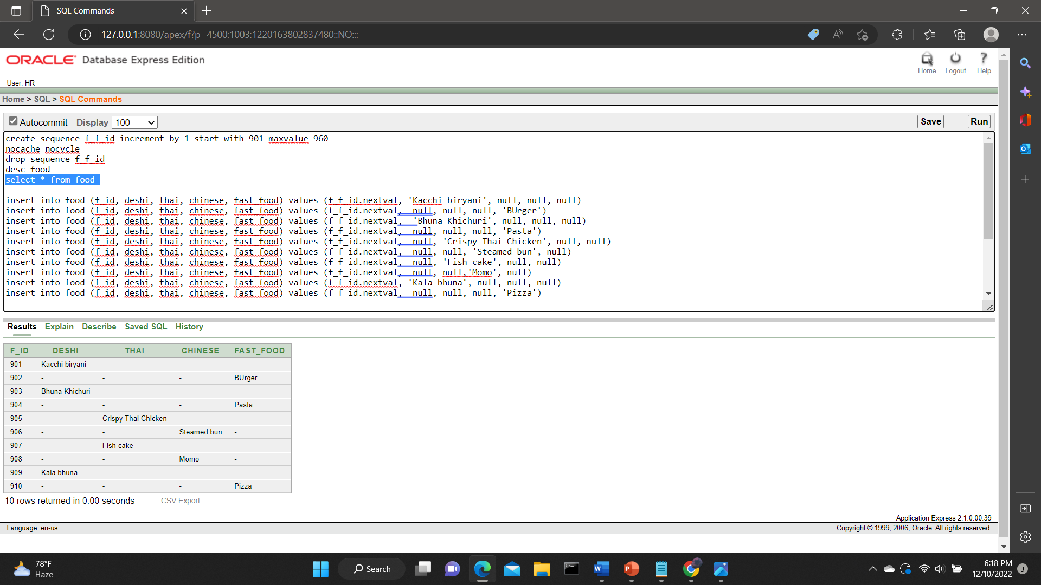

**2. DELIVERY MAN**

|  |
| --- |
| SELECT * FROM DELIVERY_MAN  CREATE SEQUENCE D_D_ID INCREMENT BY 1 START WITH 801 MAXVALUE 860  NOCACHE NOCYCLE  DESC DELIVERY_MAN  INSERT INTO DELIVERY_MAN(D_ID, D_NAME,D_PHONE) VALUES(D_D_ID.NEXTVAL, 'ALAMGIR' ,'01817165890')  INSERT INTO DELIVERY_MAN(D_ID, D_NAME,D_PHONE) VALUES(D_D_ID.NEXTVAL, 'ALAMGI' ,'01817165891')  INSERT INTO DELIVERY_MAN(D_ID, D_NAME,D_PHONE) VALUES(D_D_ID.NEXTVAL, 'ALAM' ,'01817165892')  INSERT INTO DELIVERY_MAN(D_ID, D_NAME,D_PHONE) VALUES(D_D_ID.NEXTVAL, 'ALA' ,'01817165893')  INSERT INTO DELIVERY_MAN(D_ID, D_NAME,D_PHONE) VALUES(D_D_ID.NEXTVAL, 'ALI' ,'01817165894')  INSERT INTO DELIVERY_MAN(D_ID, D_NAME,D_PHONE) VALUES(D_D_ID.NEXTVAL, 'ALIF' ,'01817165895')  INSERT INTO DELIVERY_MAN(D_ID, D_NAME,D_PHONE) VALUES(D_D_ID.NEXTVAL, 'GIR' ,'01817165896')  INSERT INTO DELIVERY_MAN(D_ID, D_NAME,D_PHONE) VALUES(D_D_ID.NEXTVAL, 'MIR' ,'01817165897')  INSERT INTO DELIVERY_MAN(D_ID, D_NAME,D_PHONE) VALUES(D_D_ID.NEXTVAL, 'RAM' ,'01817165898')  INSERT INTO DELIVERY_MAN(D_ID, D_NAME,D_PHONE) VALUES(D_D_ID.NEXTVAL, 'NAHAR' ,'01817165899') |

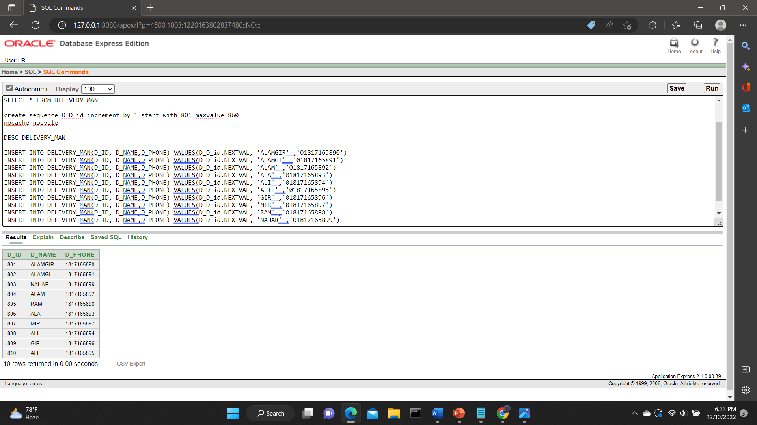**3.**

**RESTURANT1:**

|  |
| --- |
| CREATE SEQUENCE R1_R_ID INCREMENT BY 1 START WITH 701 MAXVALUE 760 NOCACHE NOCYCLE  DESC RESTURANT1  SELECT * FROM RESTURANT1  INSERT INTO RESTURANT1(R_ID, R_NAME, R_EMAIL, R_ADDRESS, R_PHONE, D_ID) VALUES (R1_R_ID.NEXTVAL , 'KFC' , 'KFC@GMAIL.COM' , 'BLOCK-6','01715142356' ,'801')  INSERT INTO RESTURANT1(R_ID, R_NAME, R_EMAIL, R_ADDRESS, R_PHONE, D_ID) VALUES (R1_R_ID.NEXTVAL , 'BFC' , 'BFC@GMAIL.COM' , 'BLOCK-7','01715142357' ,'802')  INSERT INTO RESTURANT1(R_ID, R_NAME, R_EMAIL, R_ADDRESS, R_PHONE, D_ID) VALUES (R1_R_ID.NEXTVAL , 'YUM CHA DISTRICT' , 'YUMCHACHA@GMAIL.COM' , 'BLOCK-8','01715142236' ,'803')  INSERT INTO RESTURANT1(R_ID, R_NAME, R_EMAIL, R_ADDRESS, R_PHONE, D_ID) VALUES (R1_R_ID.NEXTVAL , 'CHILLOX' , 'CHILLOX2@GMAIL.COM' , 'BLOCK-9','01715142346' ,'804')  INSERT INTO RESTURANT1(R_ID, R_NAME, R_EMAIL, R_ADDRESS, R_PHONE, D_ID) VALUES (R1_R_ID.NEXTVAL , 'CHECKERS' , 'CHECKERS2@GMAIL.COM' , 'BLOCK-2','01715142359' ,'805')  INSERT INTO RESTURANT1(R_ID, R_NAME, R_EMAIL, R_ADDRESS, R_PHONE, D_ID) VALUES (R1_R_ID.NEXTVAL , 'LA TING TING' , 'LATINGTING@GMAIL.COM' , 'BLOCK-3','01715142360' ,'806')  INSERT INTO RESTURANT1(R_ID, R_NAME, R_EMAIL, R_ADDRESS, R_PHONE, D_ID) VALUES (R1_R_ID.NEXTVAL , 'KABAB FACTORY' , 'KABABFAC@GMAIL.COM' , 'BLOCK-4','01715142307' ,'807')  INSERT INTO RESTURANT1(R_ID, R_NAME, R_EMAIL, R_ADDRESS, R_PHONE, D_ID) VALUES (R1_R_ID.NEXTVAL , 'SAO 26' , 'SAO26@GMAIL.COM' , 'BLOCK-5','01715142308' ,'808')  INSERT INTO RESTURANT1(R_ID, R_NAME, R_EMAIL, R_ADDRESS, R_PHONE, D_ID) VALUES (R1_R_ID.NEXTVAL , 'LAKE TERRACE' , 'LAKETER@GMAIL.COM' , 'BLOCK-1','01715142309' ,'809')  INSERT INTO RESTURANT1(R_ID, R_NAME, R_EMAIL, R_ADDRESS, R_PHONE, D_ID) VALUES (R1_R_ID.NEXTVAL , 'BURGER KING ' , 'BKB@GMAIL.COM' , 'BLOCK-12','01715142310' ,'810') |

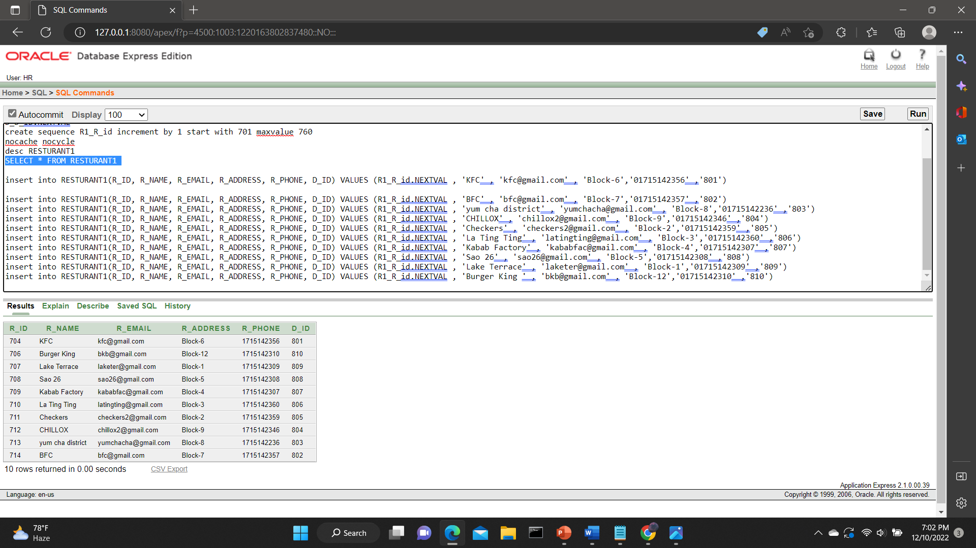

**4. CUSTOMER1:**

|  |
| --- |
| CREATE SEQUENCE C1_C_ID INCREMENT BY 1 START WITH 601 MAXVALUE 660 NOCACHE NOCYCLE  SELECT * FROM CUSTOMER1  INSERT INTO CUSTOMER1(C_ID, C_NAME, C_PHONE, C_ADDRESS, D_ID) VALUES(C1_C_ID.NEXTVAL,'AALIYAH','0134567280','H#1-R#89-BLOCK6','801')  INSERT INTO CUSTOMER1(C_ID, C_NAME, C_PHONE, C_ADDRESS, D_ID) VALUES(C1_C_ID.NEXTVAL,'DJAMILA','0134567281','H#14-R#29-BLOCK5','802')  INSERT INTO CUSTOMER1(C_ID, C_NAME, C_PHONE, C_ADDRESS, D_ID) VALUES(C1_C_ID.NEXTVAL,'ELHAM','0134567282','H#87-R#19-BLOCK1','803')  INSERT INTO CUSTOMER1(C_ID, C_NAME, C_PHONE, C_ADDRESS, D_ID) VALUES(C1_C_ID.NEXTVAL,'ISHTAR','0134567283','H#15-R#79-BLOCK7','804')  INSERT INTO CUSTOMER1(C_ID, C_NAME, C_PHONE, C_ADDRESS, D_ID) VALUES(C1_C_ID.NEXTVAL,'EHSAN','0134567384','H#4-R#4-BLOCK4','804')  INSERT INTO CUSTOMER1(C_ID, C_NAME, C_PHONE, C_ADDRESS, D_ID) VALUES(C1_C_ID.NEXTVAL,'DOLA','0134567285','H#5-R#5-BLOCK5','805')  INSERT INTO CUSTOMER1(C_ID, C_NAME, C_PHONE, C_ADDRESS, D_ID) VALUES(C1_C_ID.NEXTVAL,'WAFI','0134567286','H#16-R#66-BLOCK16','806')  INSERT INTO CUSTOMER1(C_ID, C_NAME, C_PHONE, C_ADDRESS, D_ID) VALUES(C1_C_ID.NEXTVAL,'SHARIHA','0134567287','H#17-R#87-BLOCK7','807')  INSERT INTO CUSTOMER1(C_ID, C_NAME, C_PHONE, C_ADDRESS, D_ID) VALUES(C1_C_ID.NEXTVAL,'ZAKI','0134567288','H#8-R#8-BLOCK8','808')  INSERT INTO CUSTOMER1(C_ID, C_NAME, C_PHONE, C_ADDRESS, D_ID) VALUES(C1_C_ID.NEXTVAL,'IYAD','01345672880','H#99-R#9-BLOCK9','809') |

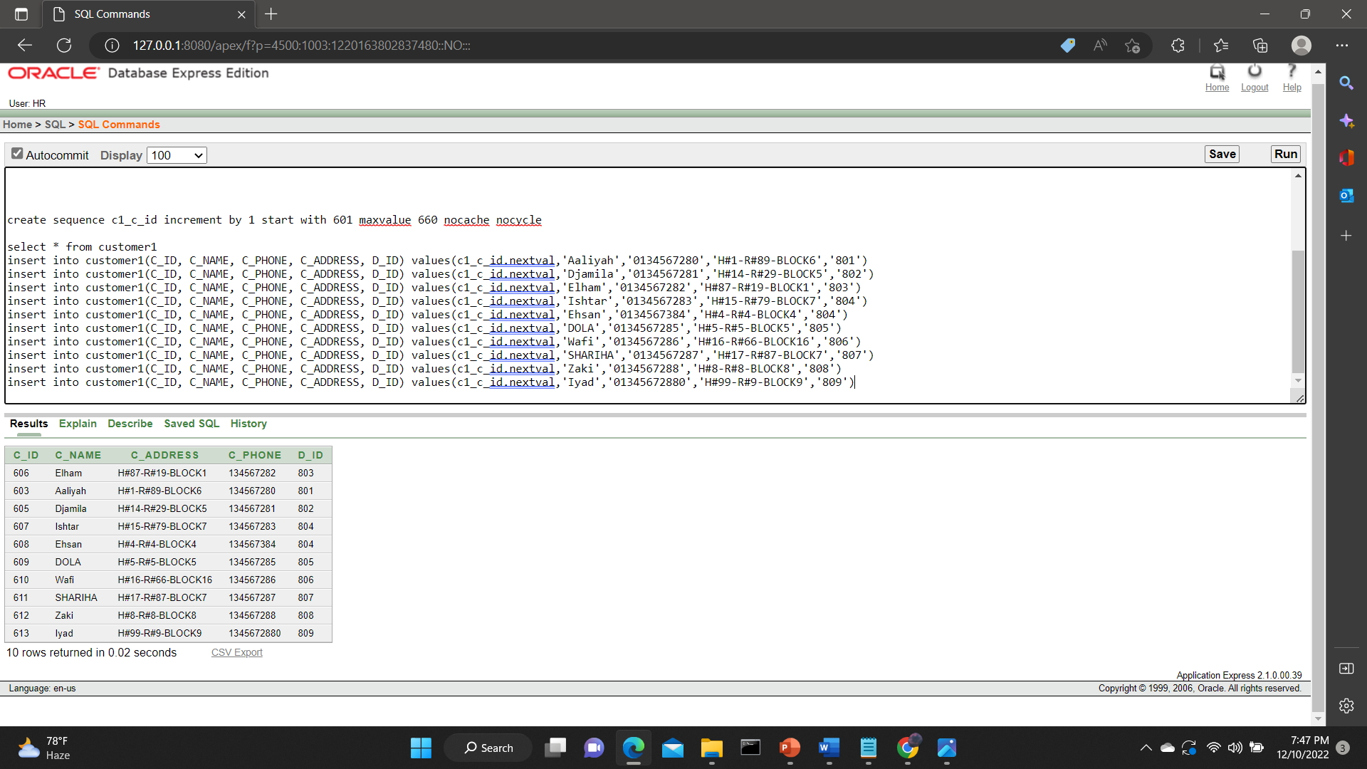

**5.EMPLOYEE:**

|  |
| --- |
| SELECT * FROM EMPLOYEE  CREATE SEQUENCE EE1_E_ID INCREMENT BY 1 START WITH 2000 MAXVALUE 2060 NOCACHE NOCYCLE  INSERT INTO EMPLOYEE(E_ID, E_NAME, E_EMAIL, AGE, E_PHONE, STAFF, CHEF, CASHIER) VALUES (EE1_E_ID.NEXTVAL,'BARKAT','BARKAT@GMAIL.COM','22','019876543','YES','YES',NULL)  INSERT INTO EMPLOYEE(E_ID, E_NAME, E_EMAIL, AGE, E_PHONE, STAFF, CHEF, CASHIER) VALUES (EE1_E_ID.NEXTVAL,'OTHOY','OTHOY@GMAIL.COM','21','019876523','YES',NULL,'YES')  INSERT INTO EMPLOYEE(E_ID, E_NAME, E_EMAIL, AGE, E_PHONE, STAFF, CHEF, CASHIER) VALUES (EE1_E_ID.NEXTVAL,'ESHTYAK','ESHHTYAK@GMAIL.COM','36','012876543','YES','YES',NULL)  INSERT INTO EMPLOYEE(E_ID, E_NAME, E_EMAIL, AGE, E_PHONE, STAFF, CHEF, CASHIER) VALUES (EE1_E_ID.NEXTVAL,'BRISHTY','BRISHTY@GMAIL.COM','34','019776543','YES','YES',NULL)  INSERT INTO EMPLOYEE(E_ID, E_NAME, E_EMAIL, AGE, E_PHONE, STAFF, CHEF, CASHIER) VALUES (EE1_E_ID.NEXTVAL,'SARA','SARA@GMAIL.COM','21','0198765423','YES','YES',NULL)  INSERT INTO EMPLOYEE(E_ID, E_NAME, E_EMAIL, AGE, E_PHONE, STAFF, CHEF, CASHIER) VALUES (EE1_E_ID.NEXTVAL,'ZAARA','ZAARA@GMAIL.COM','20','019870543','YES','YES',NULL)  INSERT INTO EMPLOYEE(E_ID, E_NAME, E_EMAIL, AGE, E_PHONE, STAFF, CHEF, CASHIER) VALUES (EE1_E_ID.NEXTVAL,'RAHMAN','RAHMANN@GMAIL.COM','25','019846503','YES','YES',NULL)  INSERT INTO EMPLOYEE(E_ID, E_NAME, E_EMAIL, AGE, E_PHONE, STAFF, CHEF, CASHIER) VALUES (EE1_E_ID.NEXTVAL,'AMAN','AMAN@GMAIL.COM','25','019876043','YES','YES',NULL)  INSERT INTO EMPLOYEE(E_ID, E_NAME, E_EMAIL, AGE, E_PHONE, STAFF, CHEF, CASHIER) VALUES (EE1_E_ID.NEXTVAL,'KAT','KAT@GMAIL.COM','44','019876543','YES',NULL,'YES')  INSERT INTO EMPLOYEE(E_ID, E_NAME, E_EMAIL, AGE, E_PHONE, STAFF, CHEF, CASHIER) VALUES (EE1_E_ID.NEXTVAL,'BARAT','BARAT@GMAIL.COM','62','019870543','YES',NULL,'YES') |

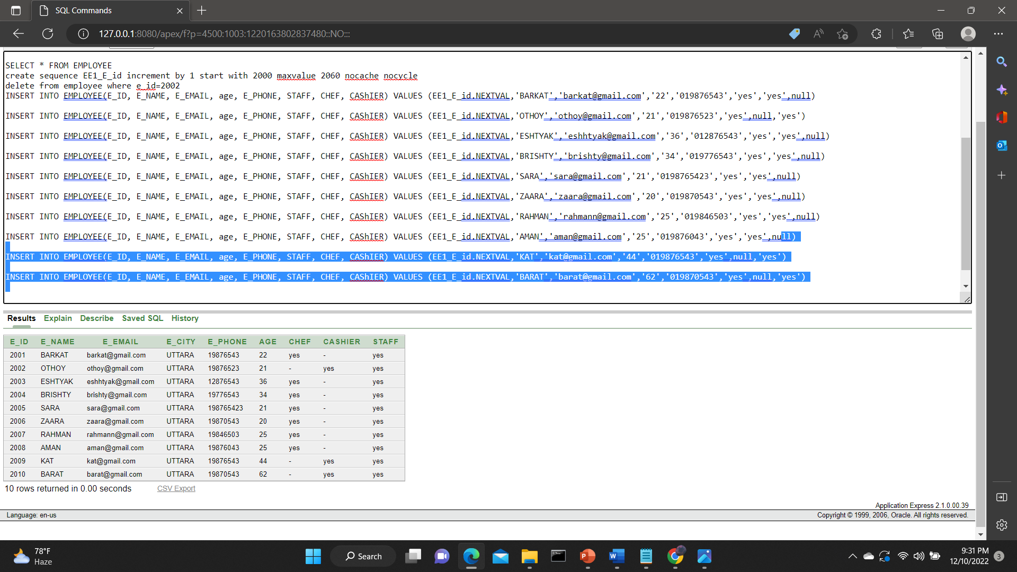

**6. MENU:**

|  |
| --- |
| CREATE SEQUENCE M1_E_ID INCREMENT BY 1 START WITH 1 MAXVALUE 60 NOCACHE NOCYCLE  SELECT * FROM MENU  INSERT INTO MENU(M_ID)VALUES(M1_E_ID.NEXTVAL)  INSERT INTO MENU(M_ID)VALUES(M1_E_ID.NEXTVAL)  INSERT INTO MENU(M_ID)VALUES(M1_E_ID.NEXTVAL)  INSERT INTO MENU(M_ID)VALUES(M1_E_ID.NEXTVAL)  INSERT INTO MENU(M_ID)VALUES(M1_E_ID.NEXTVAL)  INSERT INTO MENU(M_ID)VALUES(M1_E_ID.NEXTVAL)  INSERT INTO MENU(M_ID)VALUES(M1_E_ID.NEXTVAL)  INSERT INTO MENU(M_ID)VALUES(M1_E_ID.NEXTVAL)  INSERT INTO MENU(M_ID)VALUES(M1_E_ID.NEXTVAL)  INSERT INTO MENU(M_ID)VALUES(M1_E_ID.NEXTVAL) |

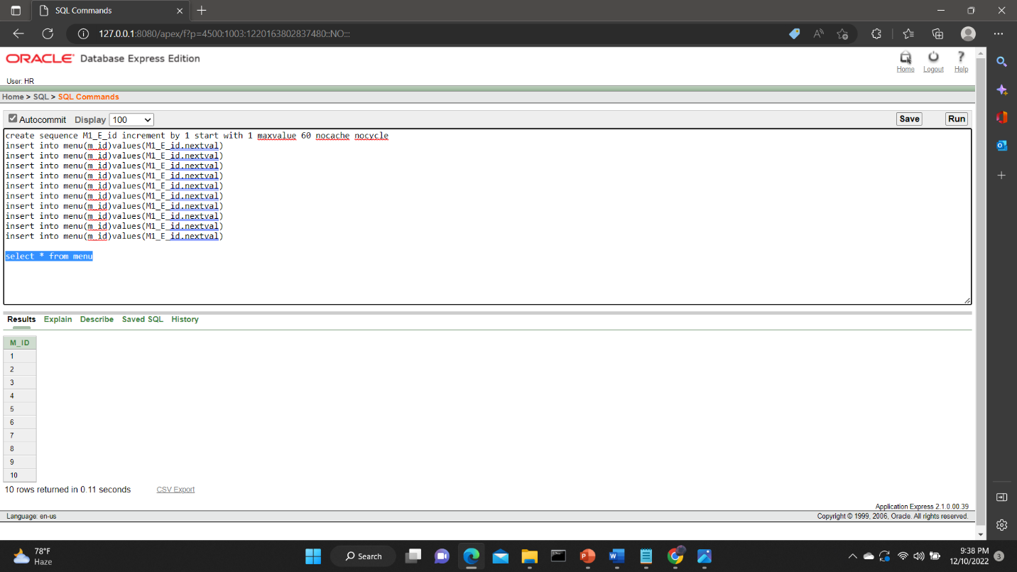

**7. FM:**

|  |
| --- |
| create sequence FM1_FM_id increment by 1 start with 1001 maxvalue 1060 nocache nocycle  SELECT * FROM FM  INSERT INTO FM(FM_ID, F_ID, M_ID)VALUES(FM1_FM_id.NEXTVAL,'901','1 ')  INSERT INTO FM(FM_ID, F_ID, M_ID)VALUES(FM1_FM_id.NEXTVAL,'902','2 ')  INSERT INTO FM(FM_ID, F_ID, M_ID)VALUES(FM1_FM_id.NEXTVAL,'903','3 ')  INSERT INTO FM(FM_ID, F_ID, M_ID)VALUES(FM1_FM_id.NEXTVAL,'904','4 ')  INSERT INTO FM(FM_ID, F_ID, M_ID)VALUES(FM1_FM_id.NEXTVAL,'905','5 ')  INSERT INTO FM(FM_ID, F_ID, M_ID)VALUES(FM1_FM_id.NEXTVAL,'906','6 ')  INSERT INTO FM(FM_ID, F_ID, M_ID)VALUES(FM1_FM_id.NEXTVAL,'907','7 ')  INSERT INTO FM(FM_ID, F_ID, M_ID)VALUES(FM1_FM_id.NEXTVAL,'908','8 ')  INSERT INTO FM(FM_ID, F_ID, M_ID)VALUES(FM1_FM_id.NEXTVAL,'909','9 ')  INSERT INTO FM(FM_ID, F_ID, M_ID)VALUES(FM1_FM_id.NEXTVAL,'910','10 ') |

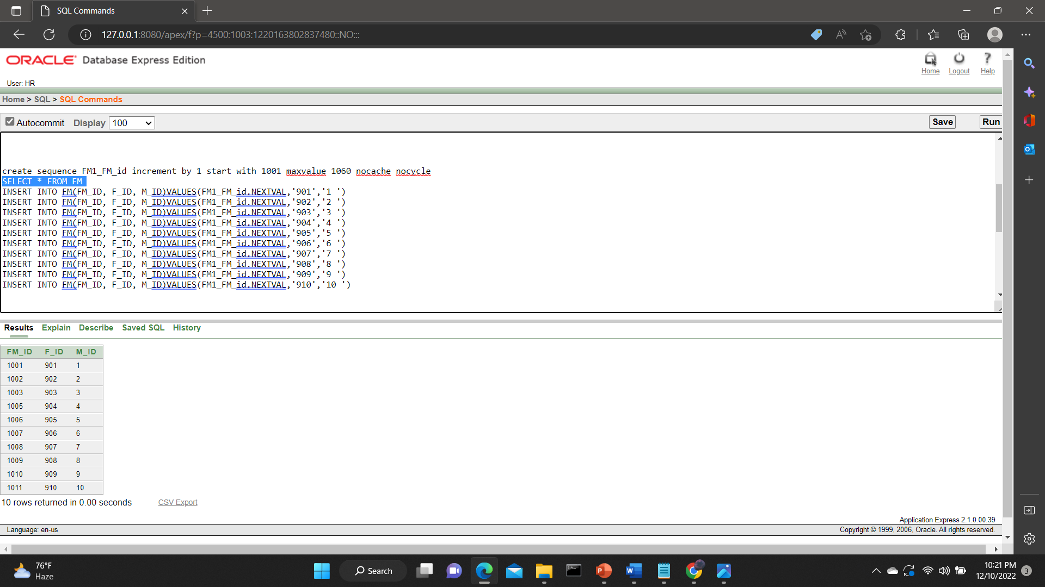

**8.MAIN COURSE:**

|  |
| --- |
| table main course  desc MAIN_COURSE  select * from MAIN_COURSE  create sequence Mc1_mc_id increment by 1 start with 1101 maxvalue 1160 nocache nocycle  insert into MAIN_COURSE(mc_id)values(Mc1_mc_id.nextval)  insert into MAIN_COURSE(mc_id)values(Mc1_mc_id.nextval)  insert into MAIN_COURSE(mc_id)values(Mc1_mc_id.nextval)  insert into MAIN_COURSE(mc_id)values(Mc1_mc_id.nextval)  insert into MAIN_COURSE(mc_id)values(Mc1_mc_id.nextval)  insert into MAIN_COURSE(mc_id)values(Mc1_mc_id.nextval)  insert into MAIN_COURSE(mc_id)values(Mc1_mc_id.nextval)  insert into MAIN_COURSE(mc_id)values(Mc1_mc_id.nextval)  insert into MAIN_COURSE(mc_id)values(Mc1_mc_id.nextval)  insert into MAIN_COURSE(mc_id)values(Mc1_mc_id.nextval) |

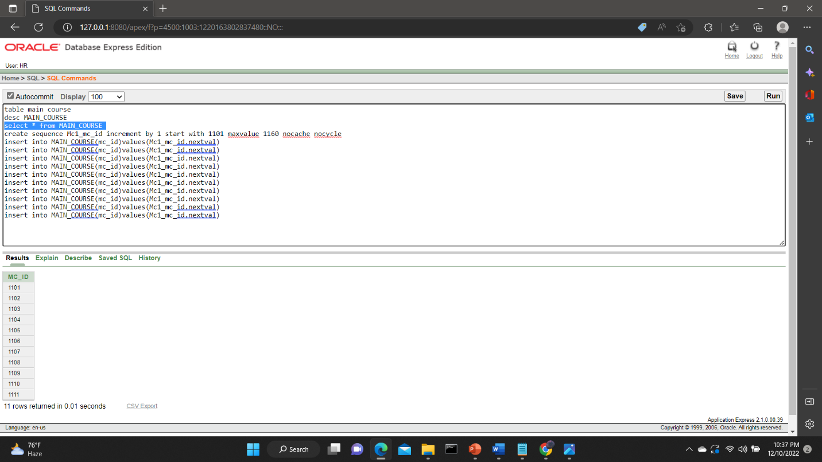

**9.QTN**

|  |
| --- |
| TABLE QNT  CREATE SEQUENCE Q_Q_ID INCREMENT BY 1 START WITH 1201 MAXVALUE 1260 NOCACHE NOCYCLE  CREATE SEQUENCE Q1_Q1_ID INCREMENT BY 1 START WITH 1 MAXVALUE 100 NOCACHE NOCYCLE  DESC QNT  INSERT INTO QNT(QNT_ID, QUANTITY, TOTAL_COST,NO_OF_ORDER)VALUES(Q_Q_ID.NEXTVAL,'2','540',Q1_Q1_ID.NEXTVAL)  INSERT INTO QNT(QNT_ID, QUANTITY, TOTAL_COST,NO_OF_ORDER)VALUES(Q_Q_ID.NEXTVAL,'1','100',Q1_Q1_ID.NEXTVAL)  INSERT INTO QNT(QNT_ID, QUANTITY, TOTAL_COST,NO_OF_ORDER)VALUES(Q_Q_ID.NEXTVAL,'5','2000',Q1_Q1_ID.NEXTVAL)  INSERT INTO QNT(QNT_ID, QUANTITY, TOTAL_COST,NO_OF_ORDER)VALUES(Q_Q_ID.NEXTVAL,'3','500',Q1_Q1_ID.NEXTVAL)  INSERT INTO QNT(QNT_ID, QUANTITY, TOTAL_COST,NO_OF_ORDER)VALUES(Q_Q_ID.NEXTVAL,'2','800',Q1_Q1_ID.NEXTVAL)  INSERT INTO QNT(QNT_ID, QUANTITY, TOTAL_COST,NO_OF_ORDER)VALUES(Q_Q_ID.NEXTVAL,'2','540',Q1_Q1_ID.NEXTVAL)  INSERT INTO QNT(QNT_ID, QUANTITY, TOTAL_COST,NO_OF_ORDER)VALUES(Q_Q_ID.NEXTVAL,'10','2050',Q1_Q1_ID.NEXTVAL)  INSERT INTO QNT(QNT_ID, QUANTITY, TOTAL_COST,NO_OF_ORDER)VALUES(Q_Q_ID.NEXTVAL,'1','370',Q1_Q1_ID.NEXTVAL)  INSERT INTO QNT(QNT_ID, QUANTITY, TOTAL_COST,NO_OF_ORDER)VALUES(Q_Q_ID.NEXTVAL,'5','490',Q1_Q1_ID.NEXTVAL)  INSERT INTO QNT(QNT_ID, QUANTITY, TOTAL_COST,NO_OF_ORDER)VALUES(Q_Q_ID.NEXTVAL,'4','670',Q1_Q1_ID.NEXTVAL)  SELECT* FROM QNT |

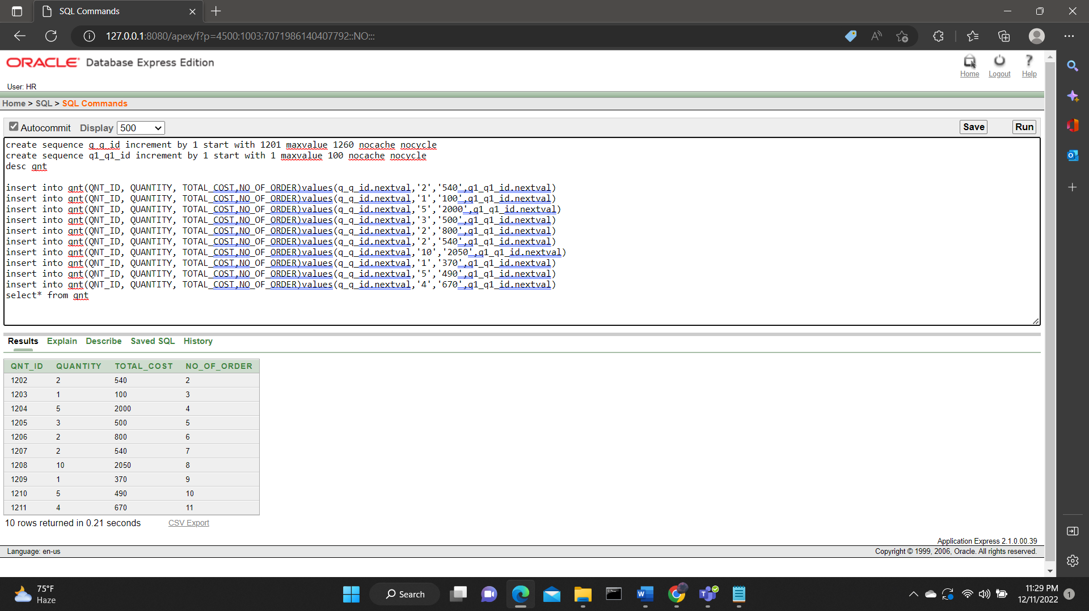

**10. BEVERAGE**

|  |
| --- |
| TABLE BEVERAGE  CREATE SEQUENCE B_B_ID INCREMENT BY 1 START WITH 1161 MAXVALUE 1191 NOCACHE NOCYCLE  INSERT INTO BEVERAGE(B_ID)VALUES(B_B_ID.NEXTVAL)  INSERT INTO BEVERAGE(B_ID)VALUES(B_B_ID.NEXTVAL)  INSERT INTO BEVERAGE(B_ID)VALUES(B_B_ID.NEXTVAL)  INSERT INTO BEVERAGE(B_ID)VALUES(B_B_ID.NEXTVAL)  INSERT INTO BEVERAGE(B_ID)VALUES(B_B_ID.NEXTVAL)  INSERT INTO BEVERAGE(B_ID)VALUES(B_B_ID.NEXTVAL)  INSERT INTO BEVERAGE(B_ID)VALUES(B_B_ID.NEXTVAL)  INSERT INTO BEVERAGE(B_ID)VALUES(B_B_ID.NEXTVAL)  INSERT INTO BEVERAGE(B_ID)VALUES(B_B_ID.NEXTVAL)  INSERT INTO BEVERAGE(B_ID)VALUES(B_B_ID.NEXTVAL)  SELECT * FROM BEVERAGE |

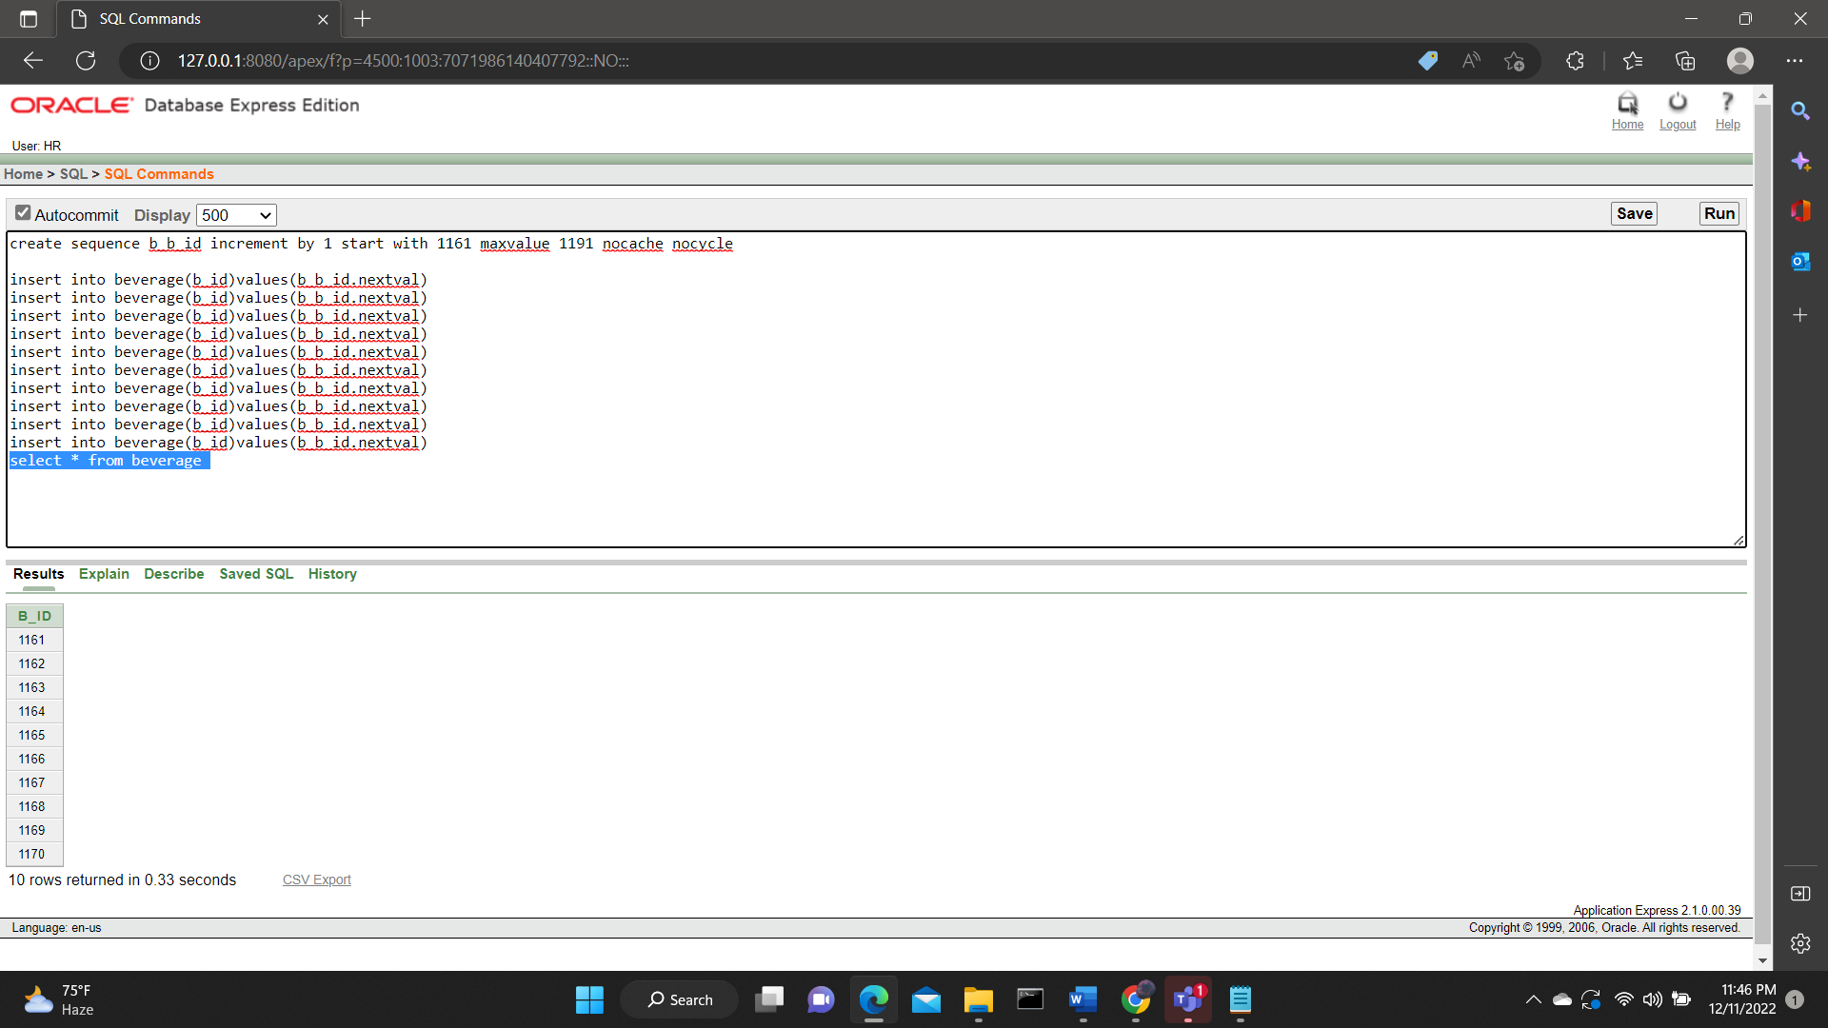

**11.MMB**

|  |
| --- |
| TABLE MMB  CREATE SEQUENCE MMB_MMB_ID INCREMENT BY 1 START WITH 301 MAXVALUE 360 NOCACHE NOCYCLE  SELECT * FROM MENU  SELECT * FROM BEVERAGE  SELECT * FROM MMB  INSERT INTO MMB(MMB_ID, M_ID, B_ID)VALUES(MMB_MMB_ID.NEXTVAL,'1','1161')  INSERT INTO MMB(MMB_ID, M_ID, B_ID)VALUES(MMB_MMB_ID.NEXTVAL,'2','1162')  INSERT INTO MMB(MMB_ID, M_ID, B_ID)VALUES(MMB_MMB_ID.NEXTVAL,'3','1163')  INSERT INTO MMB(MMB_ID, M_ID, B_ID)VALUES(MMB_MMB_ID.NEXTVAL,'4','1164')  INSERT INTO MMB(MMB_ID, M_ID, B_ID)VALUES(MMB_MMB_ID.NEXTVAL,'5','1165')  INSERT INTO MMB(MMB_ID, M_ID, B_ID)VALUES(MMB_MMB_ID.NEXTVAL,'6','1166')  INSERT INTO MMB(MMB_ID, M_ID, B_ID)VALUES(MMB_MMB_ID.NEXTVAL,'7','1167')  INSERT INTO MMB(MMB_ID, M_ID, B_ID)VALUES(MMB_MMB_ID.NEXTVAL,'8','1168')  INSERT INTO MMB(MMB_ID, M_ID, B_ID)VALUES(MMB_MMB_ID.NEXTVAL,'9','1169')  INSERT INTO MMB(MMB_ID, M_ID, B_ID)VALUES(MMB_MMB_ID.NEXTVAL,'10','1170') |

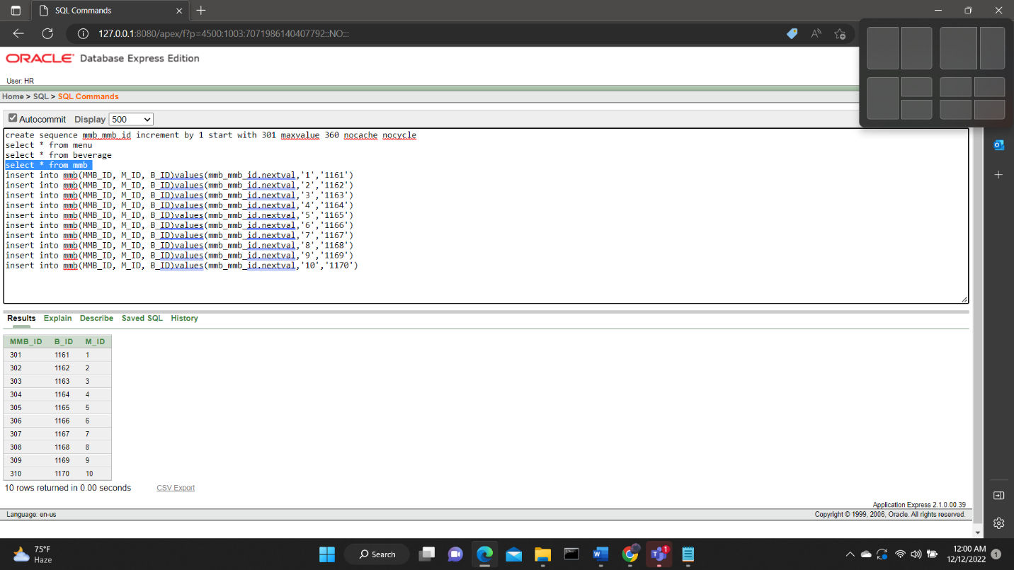

**12.MMC**

|  |
| --- |
| TABLE MMC  CREATE SEQUENCE MMC_MMC_ID INCREMENT BY 1 START WITH 361 MAXVALUE 391 NOCACHE NOCYCLE  SELECT * FROM MENU  SELECT * FROM BEVERAGE  SELECT * FROM MAIN_COURSE  SELECT * FROM MMB  SELECT * FROM MMC  DESC MMC  INSERT INTO MMC(MMC_ID, M_ID, MC_ID)VALUES(MMC_MMC_ID.NEXTVAL,'1','1101')  INSERT INTO MMC(MMC_ID, M_ID, MC_ID)VALUES(MMC_MMC_ID.NEXTVAL,'2','1102')  INSERT INTO MMC(MMC_ID, M_ID, MC_ID)VALUES(MMC_MMC_ID.NEXTVAL,'3','1103')  INSERT INTO MMC(MMC_ID, M_ID, MC_ID)VALUES(MMC_MMC_ID.NEXTVAL,'4','1104')  INSERT INTO MMC(MMC_ID, M_ID, MC_ID)VALUES(MMC_MMC_ID.NEXTVAL,'5','1105')  INSERT INTO MMC(MMC_ID, M_ID, MC_ID)VALUES(MMC_MMC_ID.NEXTVAL,'6','1106')  INSERT INTO MMC(MMC_ID, M_ID, MC_ID)VALUES(MMC_MMC_ID.NEXTVAL,'7','1107')  INSERT INTO MMC(MMC_ID, M_ID, MC_ID)VALUES(MMC_MMC_ID.NEXTVAL,'8','1108')  INSERT INTO MMC(MMC_ID, M_ID, MC_ID)VALUES(MMC_MMC_ID.NEXTVAL,'9','1109')  INSERT INTO MMC(MMC_ID, M_ID, MC_ID)VALUES(MMC_MMC_ID.NEXTVAL,'10','1110') |

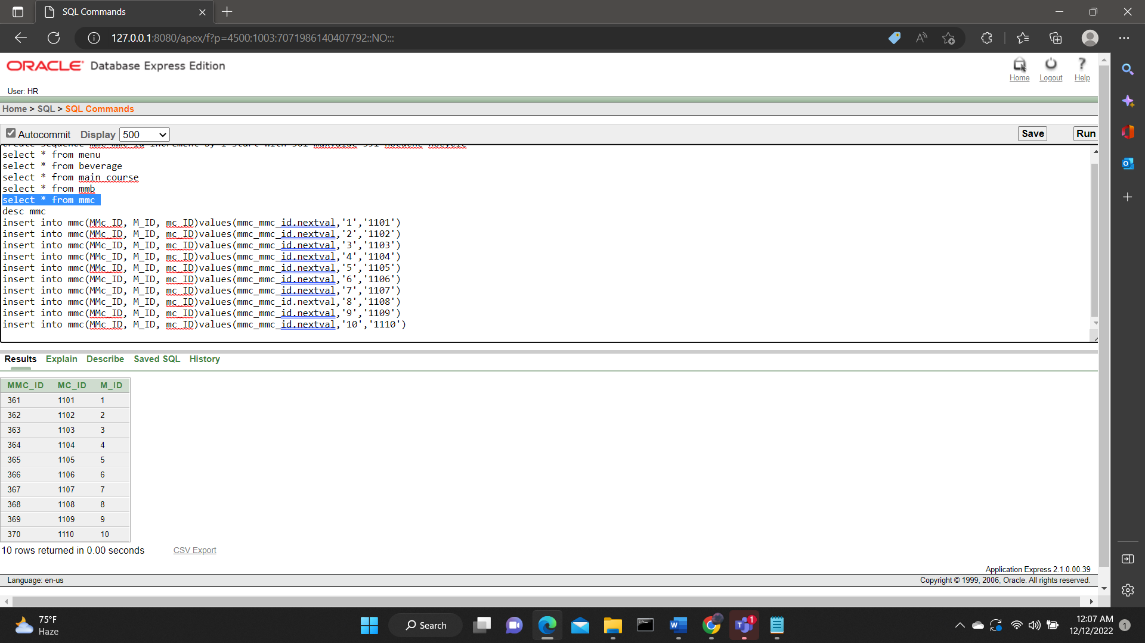

**13.ORDER**

|  |
| --- |
| SELECT * FROM ORD  CREATE SEQUENCE O1_O_ID INCREMENT BY 1 START WITH 401 MAXVALUE 460 NOCACHE NOCYCLE  INSERT INTO ORD(O_ID, O_DATE, QUANTITY, TOTAL_COST, NO_OF_ORDER)VALUES(O1_O_ID.NEXTVAL,'02-DEC-12','2','540',Q1_Q1_ID.NEXTVAL)  INSERT INTO ORD(O_ID, O_DATE, QUANTITY, TOTAL_COST, NO_OF_ORDER)VALUES(O1_O_ID.NEXTVAL,'12-JAN-12','1','100',Q1_Q1_ID.NEXTVAL)  INSERT INTO ORD(O_ID, O_DATE, QUANTITY, TOTAL_COST, NO_OF_ORDER)VALUES(O1_O_ID.NEXTVAL,'06-FEB-12','5','2000',Q1_Q1_ID.NEXTVAL)  INSERT INTO ORD(O_ID, O_DATE, QUANTITY, TOTAL_COST, NO_OF_ORDER)VALUES(O1_O_ID.NEXTVAL,'22-FEB-12','3','500',Q1_Q1_ID.NEXTVAL)  INSERT INTO ORD(O_ID, O_DATE, QUANTITY, TOTAL_COST, NO_OF_ORDER)VALUES(O1_O_ID.NEXTVAL,'02-DEC-12','2','800',Q1_Q1_ID.NEXTVAL)  INSERT INTO ORD(O_ID, O_DATE, QUANTITY, TOTAL_COST, NO_OF_ORDER)VALUES(O1_O_ID.NEXTVAL,'19-APR-12','2','540',Q1_Q1_ID.NEXTVAL)  INSERT INTO ORD(O_ID, O_DATE, QUANTITY, TOTAL_COST, NO_OF_ORDER)VALUES(O1_O_ID.NEXTVAL,'13-MAY-12','10','2050',Q1_Q1_ID.NEXTVAL)  INSERT INTO ORD(O_ID, O_DATE, QUANTITY, TOTAL_COST, NO_OF_ORDER)VALUES(O1_O_ID.NEXTVAL,'30-JUNE-12','1','370',Q1_Q1_ID.NEXTVAL)  INSERT INTO ORD(O_ID, O_DATE, QUANTITY, TOTAL_COST, NO_OF_ORDER)VALUES(O1_O_ID.NEXTVAL,'27-DEC-12','5','490',Q1_Q1_ID.NEXTVAL)  INSERT INTO ORD(O_ID, O_DATE, QUANTITY, TOTAL_COST, NO_OF_ORDER)VALUES(O1_O_ID.NEXTVAL,'10-DEC-12','4','670',Q1_Q1_ID.NEXTVAL) |

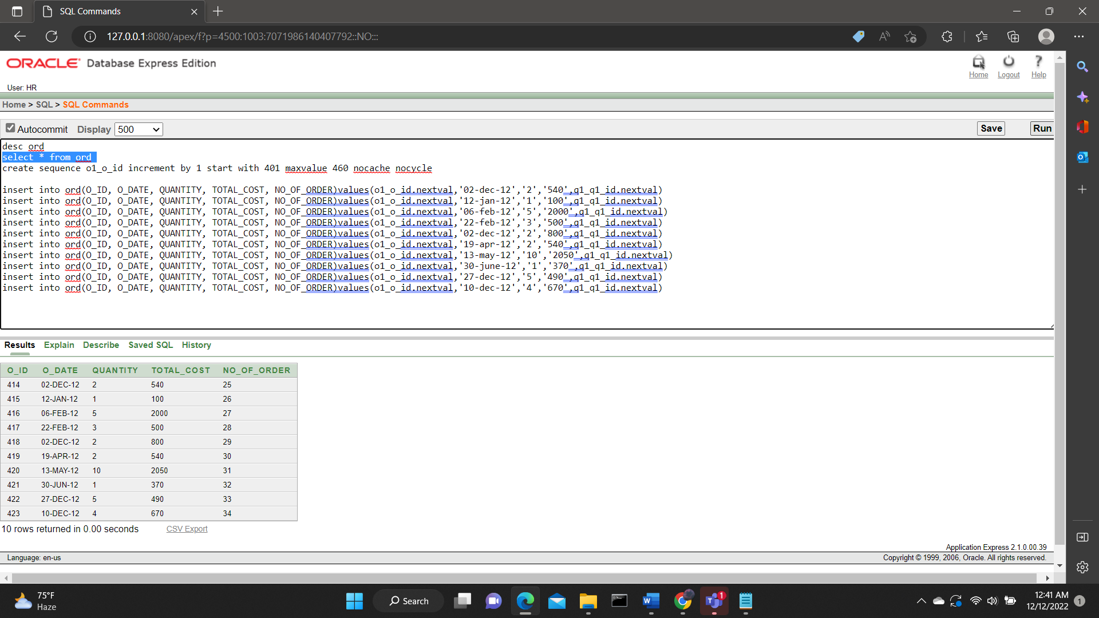

**14.PAYMENT1**

|  |
| --- |
| CREATE SEQUENCE P_P_ID INCREMENT BY 1 START WITH 501 MAXVALUE 560 NOCACHE NOCYCLE  SELECT * FROM PAYMENT1  INSERT INTO PAYMENT1(P_ID, P_TYPE, AMOUNT, CASH_ON_DELIVERY,CARD) VALUES (P_P_ID.NEXTVAL , 'CARD' , '1040' , NULL,'CONFIRMED')  INSERT INTO PAYMENT1(P_ID, P_TYPE, AMOUNT, CASH_ON_DELIVERY,CARD) VALUES (P_P_ID.NEXTVAL , 'CARD' , '390' , NULL,'CONFIRMED')  INSERT INTO PAYMENT1(P_ID, P_TYPE, AMOUNT, CASH_ON_DELIVERY,CARD) VALUES (P_P_ID.NEXTVAL , 'CASH_ON_DELIVERY' , '1250' ,'CONFIRMED', NULL)  INSERT INTO PAYMENT1(P_ID, P_TYPE, AMOUNT, CASH_ON_DELIVERY,CARD) VALUES (P_P_ID.NEXTVAL , 'CASH_ON_DELIVERY' , '1350' ,'CONFIRMED', NULL)  INSERT INTO PAYMENT1(P_ID, P_TYPE, AMOUNT, CASH_ON_DELIVERY,CARD) VALUES (P_P_ID.NEXTVAL , 'CARD' , '740' , NULL,'CONFIRMED')  INSERT INTO PAYMENT1(P_ID, P_TYPE, AMOUNT, CASH_ON_DELIVERY,CARD) VALUES (P_P_ID.NEXTVAL , 'CASH_ON_DELIVERY' , '530' ,'CONFIRMED', NULL)  INSERT INTO PAYMENT1(P_ID, P_TYPE, AMOUNT, CASH_ON_DELIVERY,CARD) VALUES (P_P_ID.NEXTVAL , 'CASH_ON_DELIVERY' , '400' ,'CONFIRMED', NULL)  INSERT INTO PAYMENT1(P_ID, P_TYPE, AMOUNT, CASH_ON_DELIVERY,CARD) VALUES (P_P_ID.NEXTVAL , 'CARD' , '890' , NULL,'CONFIRMED')  INSERT INTO PAYMENT1(P_ID, P_TYPE, AMOUNT, CASH_ON_DELIVERY,CARD) VALUES (P_P_ID.NEXTVAL , 'CASH_ON_DELIVERY' , '570' ,'CONFIRMED', NULL)  INSERT INTO PAYMENT1(P_ID, P_TYPE, AMOUNT, CASH_ON_DELIVERY,CARD) VALUES (P_P_ID.NEXTVAL , 'CASH_ON_DELIVERY' , '1180' ,'CONFIRMED', NULL) |

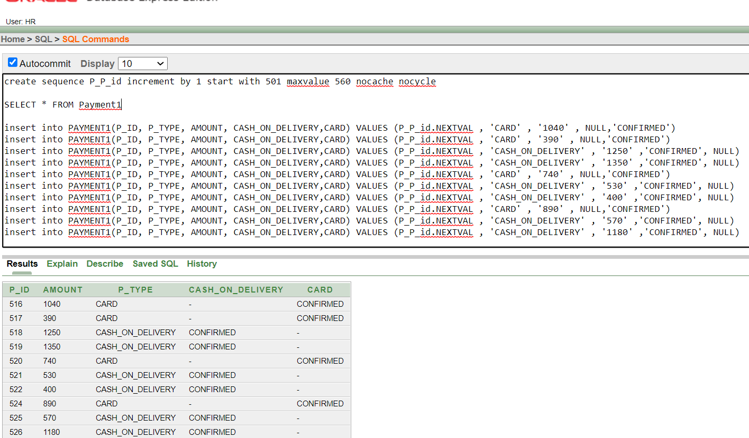

**15.RESTARUANT2**

|  |
| --- |
| CREATE SEQUENCE R2_R_ID INCREMENT BY 1 START WITH 701 MAXVALUE 760 NOCACHE NOCYCLE  DESC RESTURANT2  SELECT * FROM RESTURANT2    INSERT INTO RESTURANT2(R_ID, R_NAME, R_EMAIL, R_ADDRESS, R_PHONE, C_ID) VALUES (R1_R_ID.NEXTVAL , 'KFC' , 'KFC@GMAIL.COM' , 'BLOCK-6','01715142356' ,'601')  INSERT INTO RESTURANT2(R_ID, R_NAME, R_EMAIL, R_ADDRESS, R_PHONE, C_ID) VALUES (R1_R_ID.NEXTVAL , 'BFC' , 'BFC@GMAIL.COM' , 'BLOCK-7','01715142357' ,'602')  INSERT INTO RESTURANT2(R_ID, R_NAME, R_EMAIL, R_ADDRESS, R_PHONE, C_ID) VALUES (R1_R_ID.NEXTVAL , 'YUM CHA DISTRICT' , 'YUMCHACHA@GMAIL.COM' , 'BLOCK-8','01715142236' ,'603')  INSERT INTO RESTURANT2(R_ID, R_NAME, R_EMAIL, R_ADDRESS, R_PHONE, C_ID) VALUES (R1_R_ID.NEXTVAL , 'CHILLOX' , 'CHILLOX2@GMAIL.COM' , 'BLOCK-9','01715142346' ,'604')  INSERT INTO RESTURANT2(R_ID, R_NAME, R_EMAIL, R_ADDRESS, R_PHONE, C_ID) VALUES (R1_R_ID.NEXTVAL , 'CHECKERS' , 'CHECKERS2@GMAIL.COM' , 'BLOCK-2','01715142359' ,'605')  INSERT INTO RESTURANT2(R_ID, R_NAME, R_EMAIL, R_ADDRESS, R_PHONE, C_ID) VALUES (R1_R_ID.NEXTVAL , 'LA TING TING' , 'LATINGTING@GMAIL.COM' , 'BLOCK-3','01715142360' ,'606')  INSERT INTO RESTURANT2(R_ID, R_NAME, R_EMAIL, R_ADDRESS, R_PHONE, C_ID) VALUES (R1_R_ID.NEXTVAL , 'KABAB FACTORY' , 'KABABFAC@GMAIL.COM' , 'BLOCK-4','01715142307' ,'607')  INSERT INTO RESTURANT2(R_ID, R_NAME, R_EMAIL, R_ADDRESS, R_PHONE, C_ID) VALUES (R1_R_ID.NEXTVAL , 'SAO 26' , 'SAO26@GMAIL.COM' , 'BLOCK-5','01715142308' ,'608')  INSERT INTO RESTURANT2(R_ID, R_NAME, R_EMAIL, R_ADDRESS, R_PHONE, C_ID) VALUES (R1_R_ID.NEXTVAL , 'LAKE TERRACE' , 'LAKETER@GMAIL.COM' , 'BLOCK-1','01715142309' ,'609')  INSERT INTO RESTURANT2(R_ID, R_NAME, R_EMAIL, R_ADDRESS, R_PHONE, C_ID) VALUES (R1_R_ID.NEXTVAL , 'BURGER KING ' , 'BKB@GMAIL.COM' , 'BLOCK-12','01715142310' ,'610') |

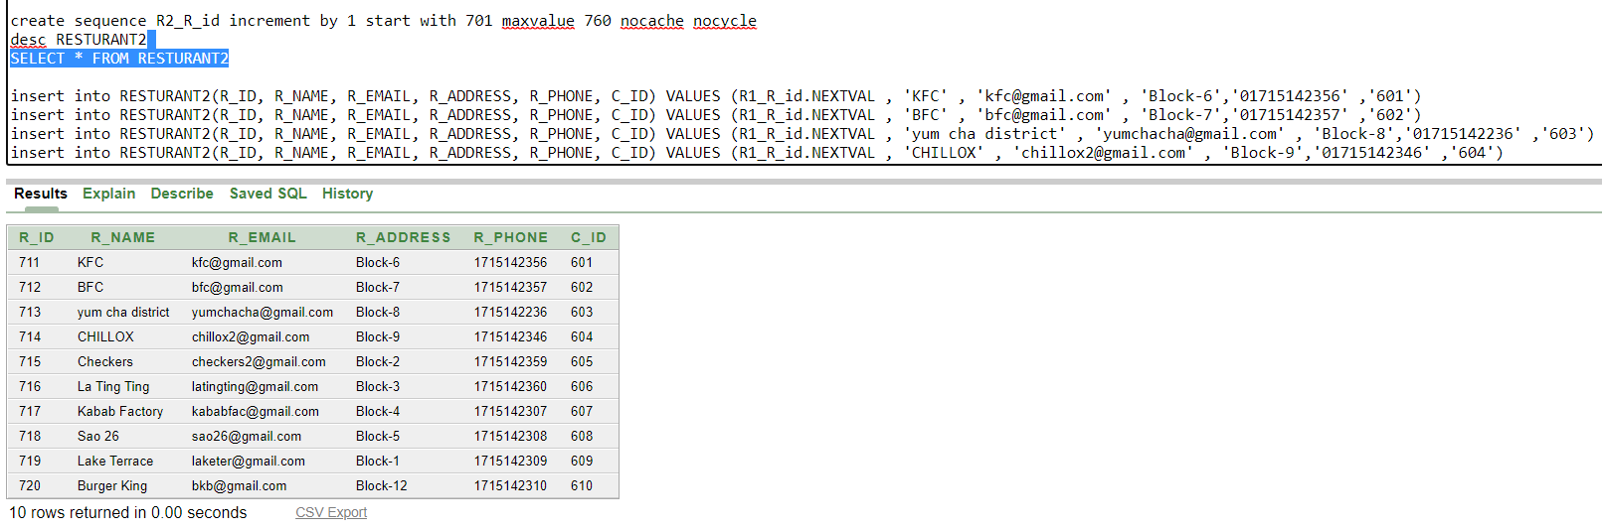

**16. FR:**

|  |
| --- |
| TABLE FR  CREATE SEQUENCE FR_FR_ID INCREMENT BY 1 START WITH 9901 MAXVALUE 9960  NOCACHE NOCYCLE  SELECT*FROM FR  INSERT INTO FR(FR_ID,F_ID,R_ID) VALUES (FR_FR_ID.NEXTVAL, '901', '701')  INSERT INTO FR(FR_ID,F_ID,R_ID) VALUES (FR_FR_ID.NEXTVAL, '902', '702')  INSERT INTO FR(FR_ID,F_ID,R_ID) VALUES (FR_FR_ID.NEXTVAL, '903', '703')  INSERT INTO FR(FR_ID,F_ID,R_ID) VALUES (FR_FR_ID.NEXTVAL, '904', '704')  INSERT INTO FR(FR_ID,F_ID,R_ID) VALUES (FR_FR_ID.NEXTVAL, '905', '705')  INSERT INTO FR(FR_ID,F_ID,R_ID) VALUES (FR_FR_ID.NEXTVAL, '906', '706')  INSERT INTO FR(FR_ID,F_ID,R_ID) VALUES (FR_FR_ID.NEXTVAL, '907', '707')  INSERT INTO FR(FR_ID,F_ID,R_ID) VALUES (FR_FR_ID.NEXTVAL, '908', '708')  INSERT INTO FR(FR_ID,F_ID,R_ID) VALUES (FR_FR_ID.NEXTVAL, '909', '709')  INSERT INTO FR(FR_ID,F_ID,R_ID) VALUES (FR_FR_ID.NEXTVAL, '910', '710') |

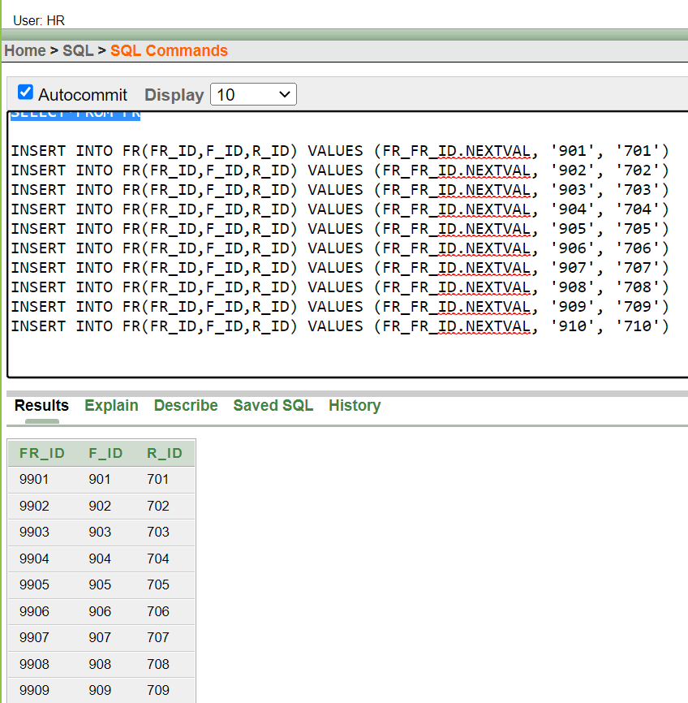

**17.CART:**

|  |
| --- |
| SELECT * FROM ORD  SELECT * FROM CART  CREATE SEQUENCE CC1_CC_ID INCREMENT BY 1 START WITH 501 MAXVALUE 560 NOCACHE NOCYCLE  INSERT INTO CART(CART_ID, NO_OF_FOOD, TOTAL_COST, O_ID) VALUES (CC1_CC_ID.NEXTVAL,'1','100','414')  INSERT INTO CART(CART_ID, NO_OF_FOOD, TOTAL_COST, O_ID)VALUES(CC1_CC_ID.NEXTVAL,'2','200','415')  INSERT INTO CART(CART_ID, NO_OF_FOOD, TOTAL_COST, O_ID)VALUES(CC1_CC_ID.NEXTVAL,'3','300','416')  INSERT INTO CART(CART_ID, NO_OF_FOOD, TOTAL_COST, O_ID)VALUES(CC1_CC_ID.NEXTVAL,'4','400','415')  INSERT INTO CART(CART_ID, NO_OF_FOOD, TOTAL_COST, O_ID)VALUES(CC1_CC_ID.NEXTVAL,'5','500','417')  INSERT INTO CART(CART_ID, NO_OF_FOOD, TOTAL_COST, O_ID)VALUES(CC1_CC_ID.NEXTVAL,'16','1600','418')  INSERT INTO CART(CART_ID, NO_OF_FOOD, TOTAL_COST, O_ID)VALUES(CC1_CC_ID.NEXTVAL,'7','700','419')  INSERT INTO CART(CART_ID, NO_OF_FOOD, TOTAL_COST, O_ID)VALUES(CC1_CC_ID.NEXTVAL,'8','800','414')  INSERT INTO CART(CART_ID, NO_OF_FOOD, TOTAL_COST, O_ID)VALUES(CC1_CC_ID.NEXTVAL,'9','900','416')  INSERT INTO CART(CART_ID, NO_OF_FOOD, TOTAL_COST, O_ID)VALUES(CC1_CC_ID.NEXTVAL,'11','1000','417') |

**19.REVIEW1:**

|  |
| --- |
| SELECT * FROM REVIEW1  DESC REVIEW  INSERT INTO REVIEW1(REVIEW1_ID, FOOD, SUGGESTIONS, COMMENTS, RATE) VALUES('1001','BURGER',NULL,'GOOD','5')  INSERT INTO REVIEW1(REVIEW1_ID, FOOD, SUGGESTIONS, COMMENTS, RATE) VALUES('1002','BIRIYANI',NULL,'EXCELLENT','8')  INSERT INTO REVIEW1(REVIEW1_ID, FOOD, SUGGESTIONS, COMMENTS, RATE) VALUES('1003','COFFEE','BLAND','BAD','2')  INSERT INTO REVIEW1(REVIEW1_ID, FOOD, SUGGESTIONS, COMMENTS, RATE) VALUES('1004','PIZZA',NULL,'GOOD','5')  INSERT INTO REVIEW1(REVIEW1_ID, FOOD, SUGGESTIONS, COMMENTS, RATE) VALUES('1005','NACHOS',NULL,'GOOD','5')  INSERT INTO REVIEW1(REVIEW1_ID, FOOD, SUGGESTIONS, COMMENTS, RATE) VALUES('1006','FRIED CHICKEN','INCLUDE SAUCE','GOOD','5')  INSERT INTO REVIEW1(REVIEW1_ID, FOOD, SUGGESTIONS, COMMENTS, RATE) VALUES('1007','KHICHURI','MORE SPICES REQUIRED','AVERAGE','3')  INSERT INTO REVIEW1(REVIEW1_ID, FOOD, SUGGESTIONS, COMMENTS, RATE) VALUES('1008','PIZZA',NULL,'GOOD','4')  INSERT INTO REVIEW1(REVIEW1_ID, FOOD, SUGGESTIONS, COMMENTS, RATE) VALUES('1009','RICE',NULL,'VERY GOOD','5')  INSERT INTO REVIEW1(REVIEW1_ID, FOOD, SUGGESTIONS, COMMENTS, RATE) VALUES('1010','SOUP','COOK WELL',NULL,'1') |

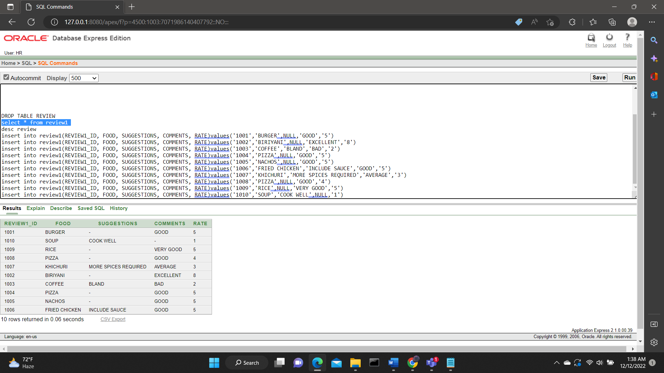

**QUERY WRITING:**

**JOINING:**

**1**. FIND THE CUSTOMER ID, NAME AND RESTURANT NAME WITH THE SAME DELIVERY ID

**ANSWER:** SELECT C1.C_ID, C1.C_NAME, C1.D_ID, R1.D_ID, R1.R_NAME

FROM CUSTOMER1 C1, RESTURANT1 R1

WHERE C1.D_ID=R1.D_ID;

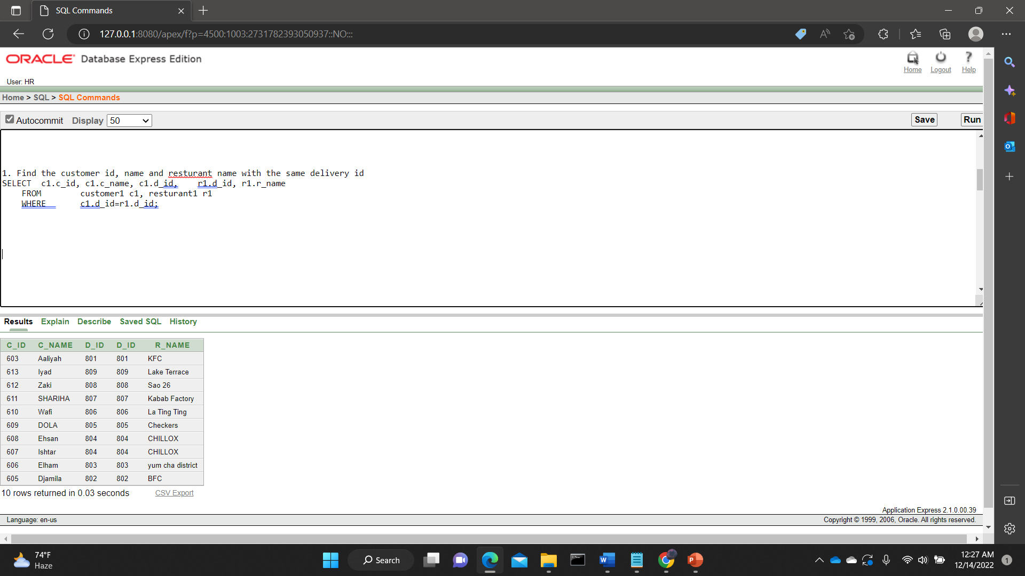

**2.** DISPLAY DELIVERY MANS NAME , ID AND WHICH RESTURANT THEY WORK FOR

**ANSWER:** SELECT D.D_ID, D.D_NAME, R1.R_NAME

FROM DELIVERY_MAN D, RESTURANT1 R1

WHERE D.D_ID=R1.D_ID;

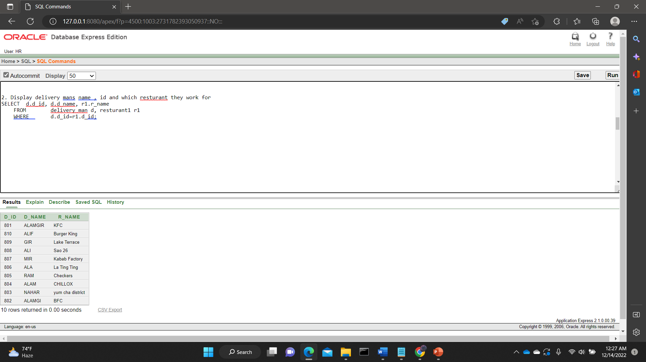

**3.** FIND EMPLOYEES WHO IS PART OF THE STAFF AND ID IS BETWEEN 2002 TO 2008

**ANSWER:** SELECT WORKER.E_NAME || ' WORK AS A STAFF -----'||WORK.STAFF STAFF_INFO

FROM EMPLOYEE WORKER, EMPLOYEE WORK

WHERE WORKER.E_ID = WORK.E_ID AND WORKER.E_ID BETWEEN 2002 AND

2008

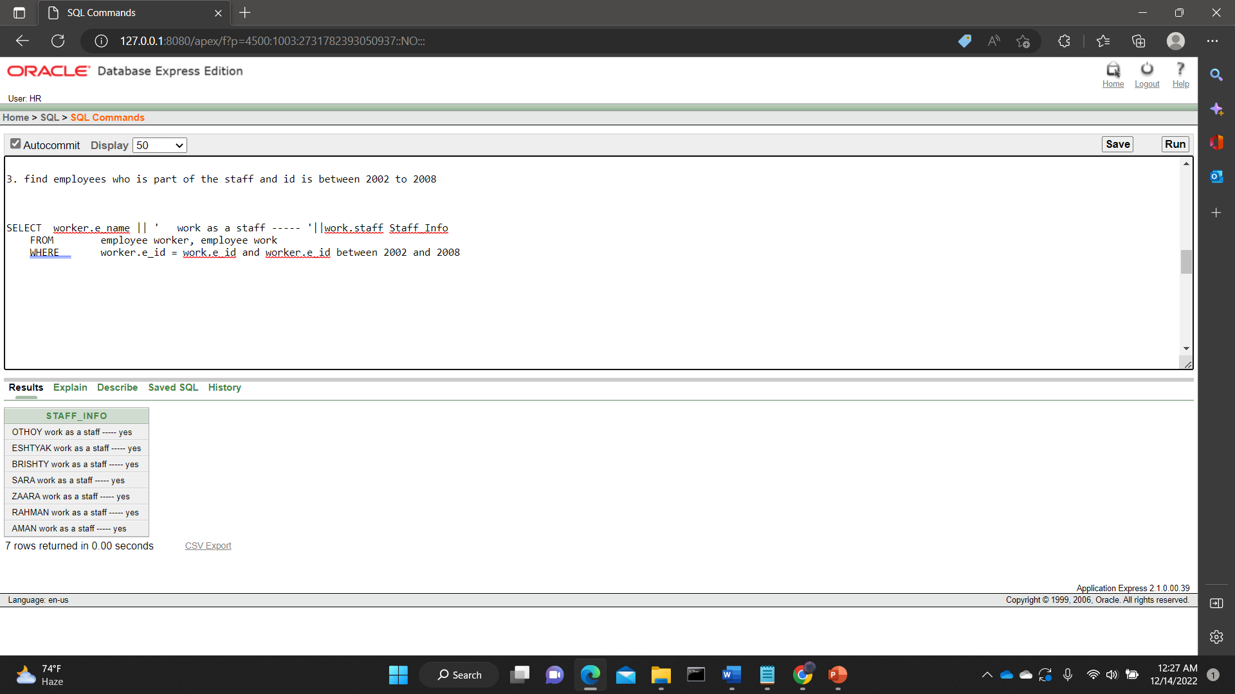

**4.**DISPLAY THE NAME OF ALL THE EMPLOYEES WHO ARE 21 YEAR OLD USING JOINING METHOD**.**

**ANSWER**: SELECT E.E_NAME, EM.AGE FROM EMPLOYEE E, EMPLOYEE EM WHERE EM.AGE = E.AGE AND E.AGE = 21

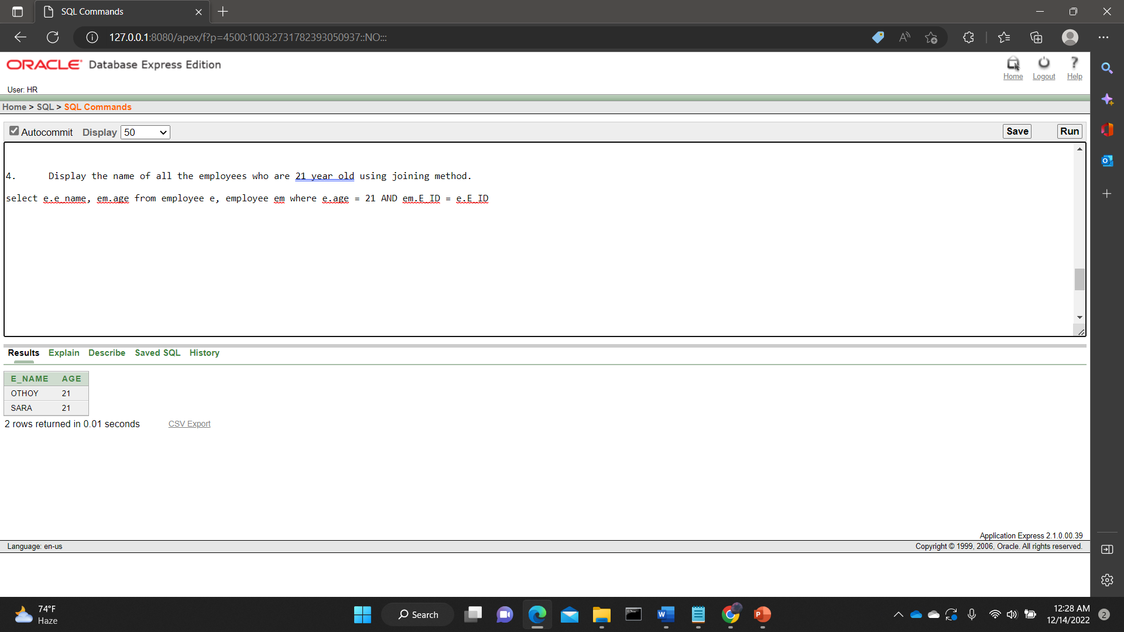

**5.**DISPLAY ALL THE DELIVERY MEN WHO DOES NOT WORK FOR KFC AND SAO 26

**ANSWER:** SELECT D.D_NAME, R.R_NAME FROM DELIVERY_MAN D, RESTURANT1 R WHERE (D.D_ID=R.D_ID) AND (R.R_NAME <> 'KFC' AND R.R_NAME <> 'SAO 26')

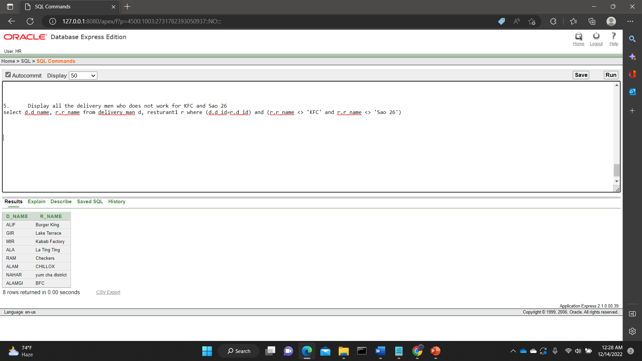

**SUB-QUERY:**

**1.** DISPLAY CUSTOMER ID, ADDRESS, PHONE OFF ALL CUSTOMERS WHOSE NAME STARTS WITH S

**ANSWER**: SELECT C_NAME,C_ID,C_ADDRESS,C_PHONE FROM CUSTOMER1

WHERE C_NAME=(SELECT C_NAME FROM CUSTOMER1 WHERE C_NAME LIKE 'S%')

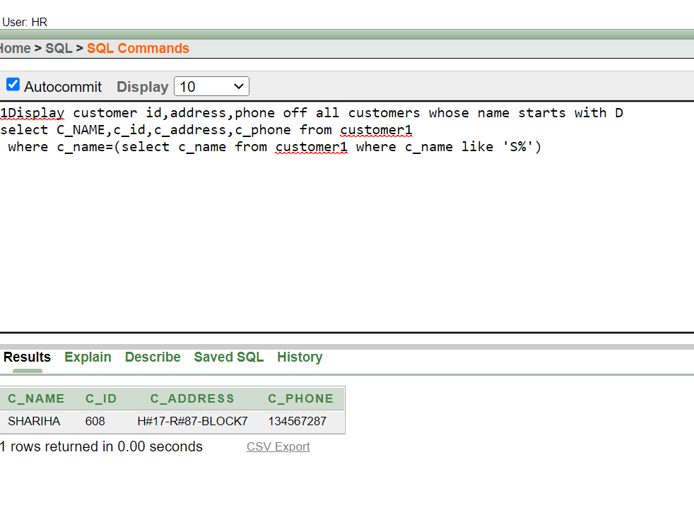

**2**.DISPLAY NAME OF CUSTOMER WHO ORDERED FOOD PASTA TABLE CUSTOMER2, FOOD

**ANSWER:** SELECT C_NAME FROM CUSTOMER2 WHERE F_ID=(SELECT F_ID FROM FOOD WHERE FAST_FOOD='PASTA' )

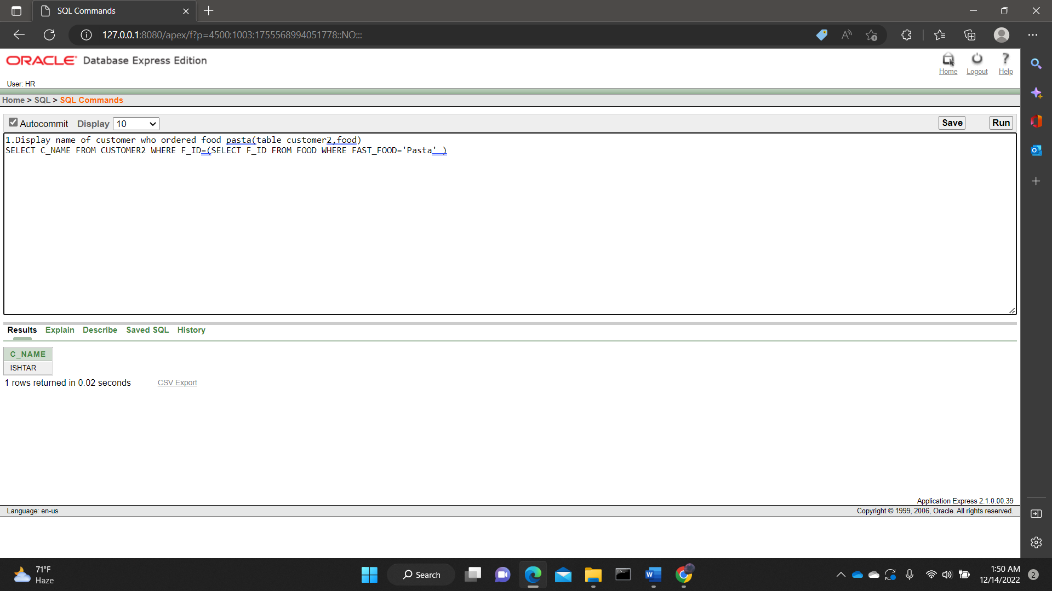

**3.** DISPLAY NOOFORDER FROM ORDER TABLE WHO ORDERED AFTER ORDERID 419

**ANSWER**: SELECT NO_OF_ORDER FROM ORD WHERE O_DATE>(SELECT O_DATE FROM ORD WHERE O_ID=419)

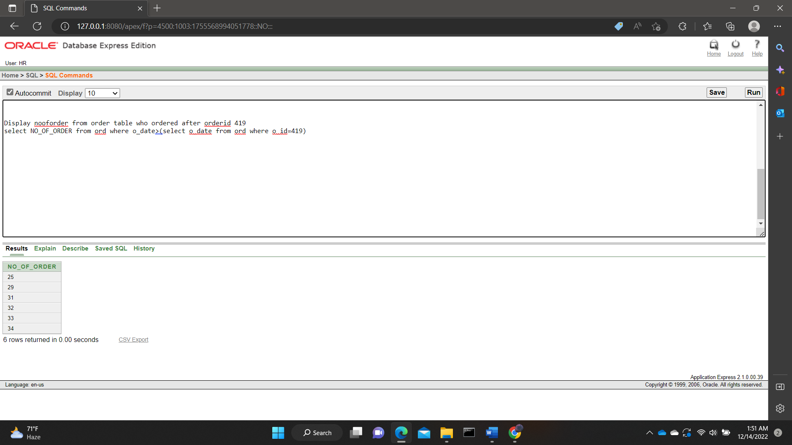

**4.**DISPLAY DELIVERY MAN NAME AND PHONE NUMBER FOR ALL DELIVERY MAN WHO DELIVERED TO BLOCK12 (FROM TABLE DELIVERYMAN, RESTURANT1**)**

**ANSWER:** SELECT D_NAME, D_PHONE FROM DELIVERY_MAN WHERE D_ID IN (SELECT D_ID FROM RESTURANT1 WHERE R_ADDRESS = 'BLOCK-12')

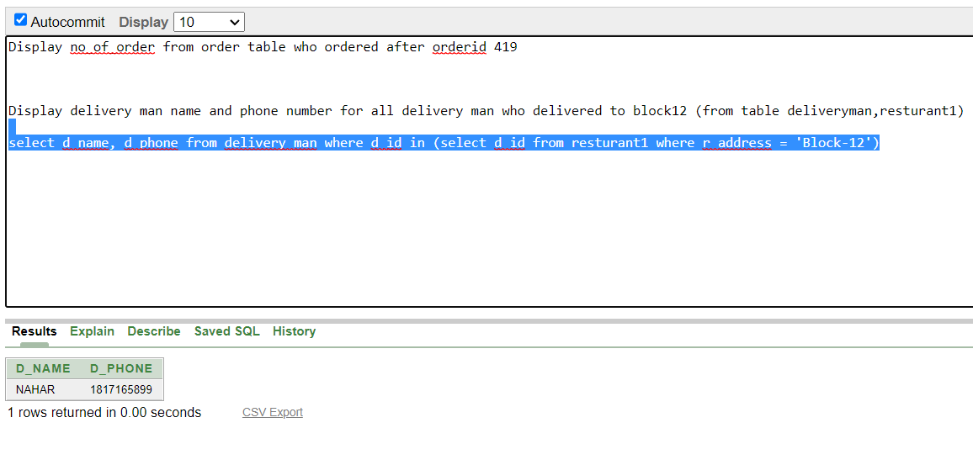

**5.** DISPLAY THE CUSTOMERS NAME AND ID WHOSE DELIVERY MAN'S ID IS 804

**ANSWER**: SELECT C_ID, C_NAME FROM CUSTOMER1 WHERE C_ADDRESS IN (SELECT C_ADDRESS FROM CUSTOMER1 WHERE D_ID = 804)

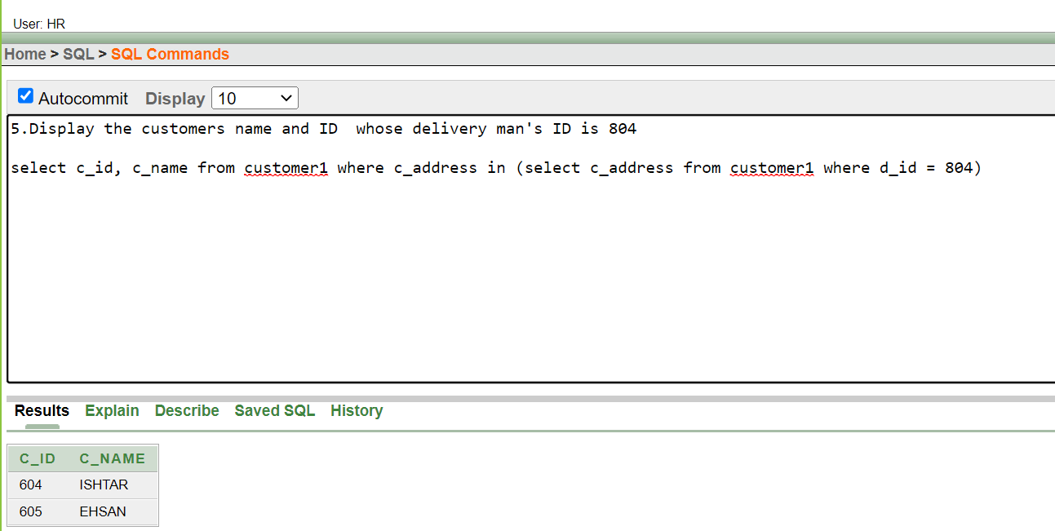

**GROUP FUNCTION**

**1.**FIND THE OLDEST AND YOUNGEST STAFF IN EMPLOYEE TABLE

**ANSWER:** SELECT MAX(AGE) OLDEST, MIN(AGE) YOUNGEST FROM EMPLOYEE

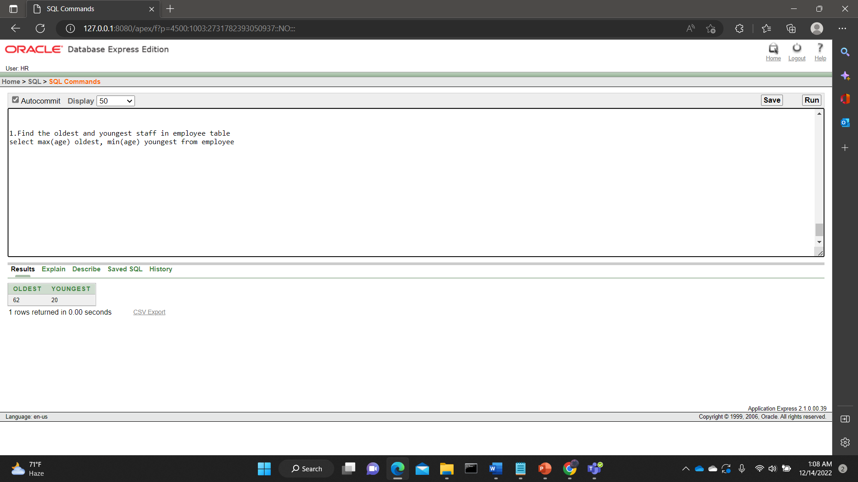

**2**.COUNT THE NUMBER OF ROW IN MENU TABLE

**ANSWER:** SELECT COUNT(*) FROM MENU

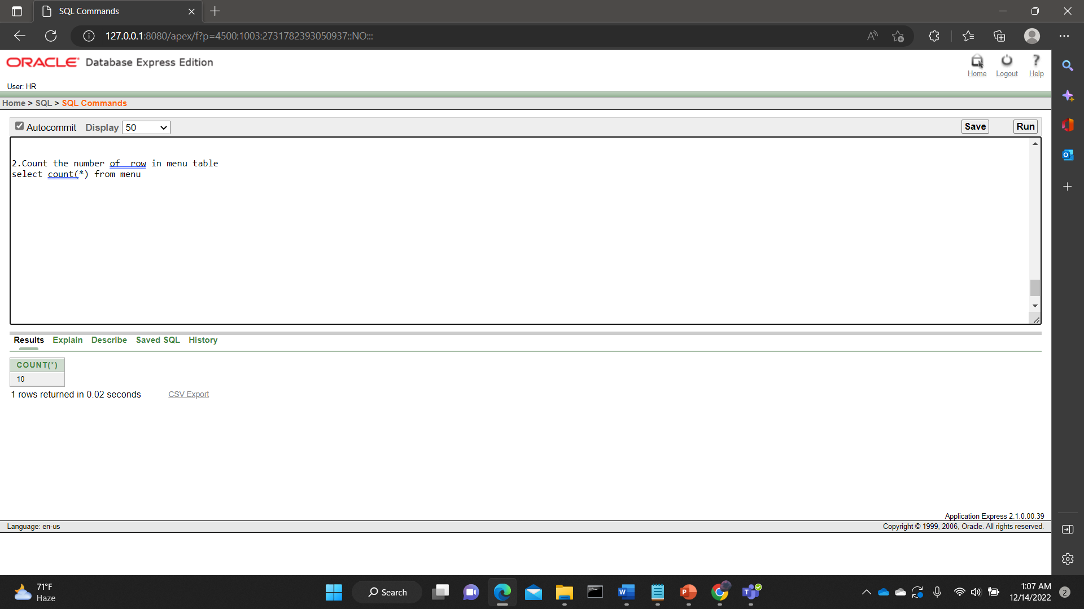

**3.** FIND EMPLOYEES WHOSE ID IS ABOVE 2007 USING GROUP FUNCTION

**ANSWER:** SELECT MAX(E_ID) MID, E_NAME FROM EMPLOYEE GROUP BY E_NAME HAVING AVG(E_ID) <2007

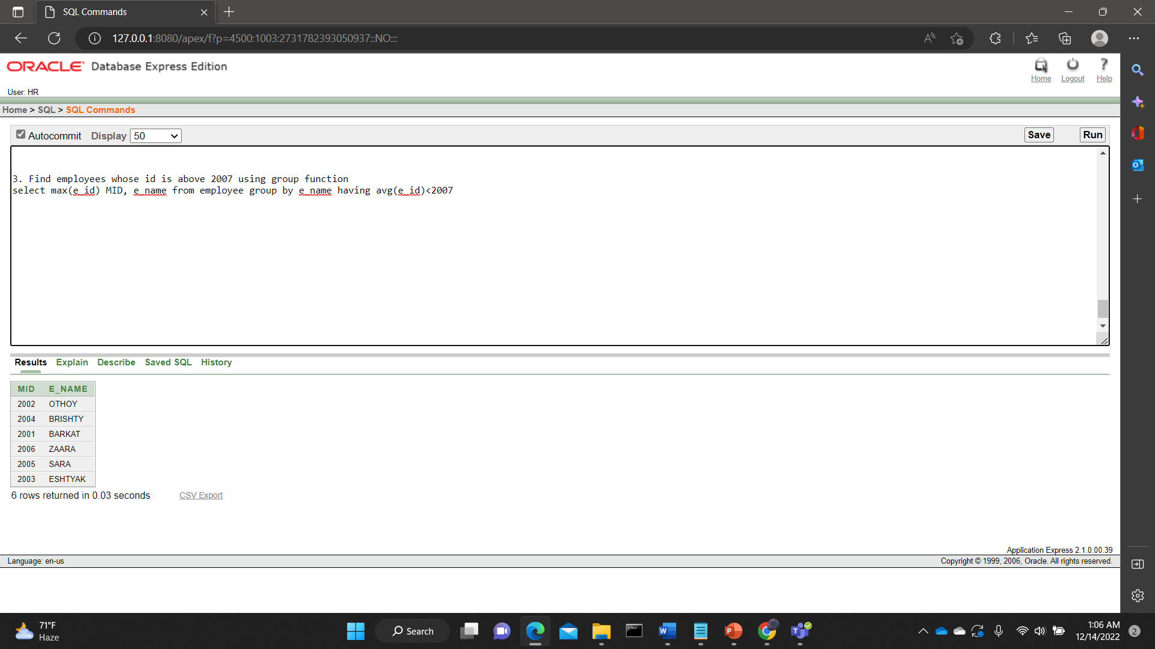

**4.** FIND THE OLDER EMPLOYEES WITH 'M' IN THEIR NAME

**ANSWER**: SELECT E_NAME, MAX(AGE) FROM EMPLOYEE WHERE E_NAME LIKE '%M%' GROUP BY E_NAME

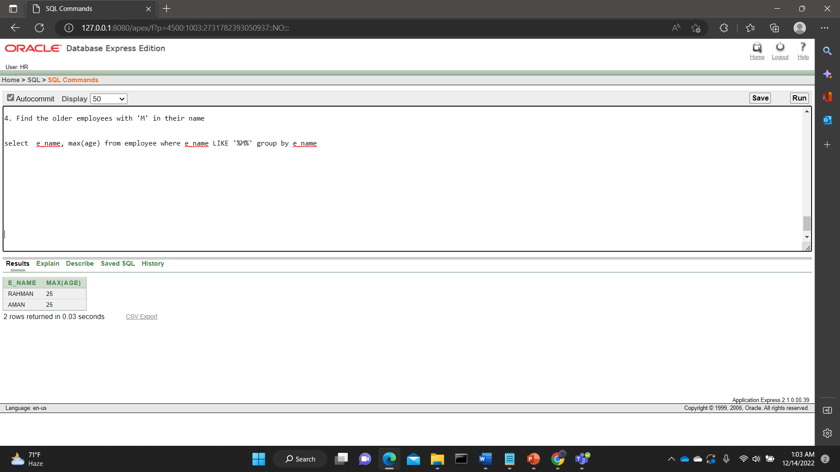

**5.** DISPLAY THE CASHIERS NAME AND ID USING GROUP FUNCTION

**ANSWER:** SELECT E_ID, E_NAME, NVL(CASHIER, 'NO') AS CASHIER FROM EMPLOYEE

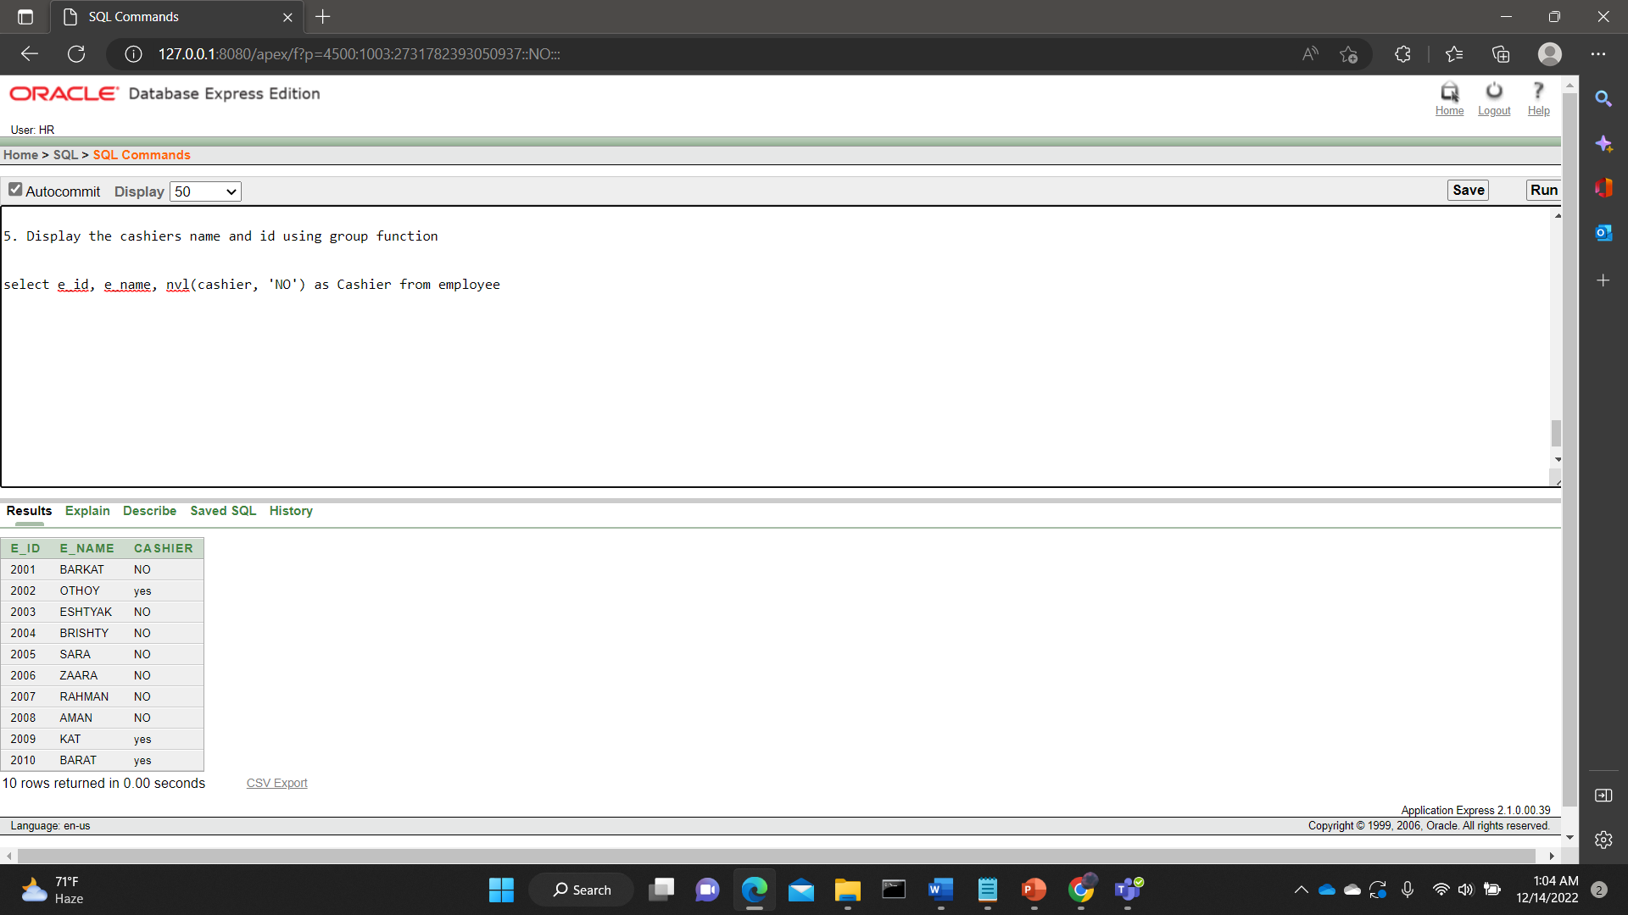

**View:**

1. CREATE A VIEW CALLED EMP_CHEF BASED ON EMPLOYEE ID, NAME AND EMAIL WHERE EMPLOYEE IS A CHEF

CREATE VIEW EMP_CHEF AS SELECT E_ID ID, E_NAME NAME, E_EMAIL EMAIL, CHEF FROM EMPLOYEE WHERE CHEF = 'YES'

SELECT * FROM EMP_CHEF

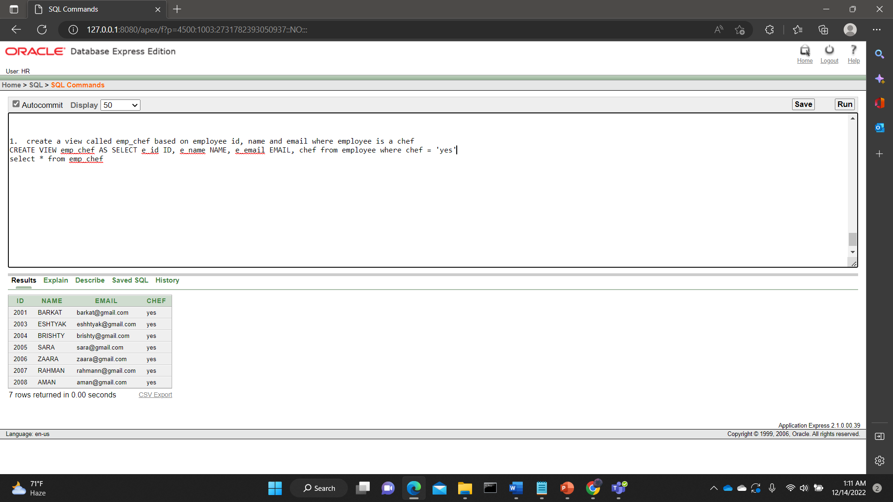

**GENERAL:**

**1.QUESTION:** SHOW CUSTOMER NAME WHO HAVE “A” IN THEIR NAME**.**

**QUERY:** SELECT C_NAME FROM CUSTOMER1 WHERE C_NAME LIKE '%A%'

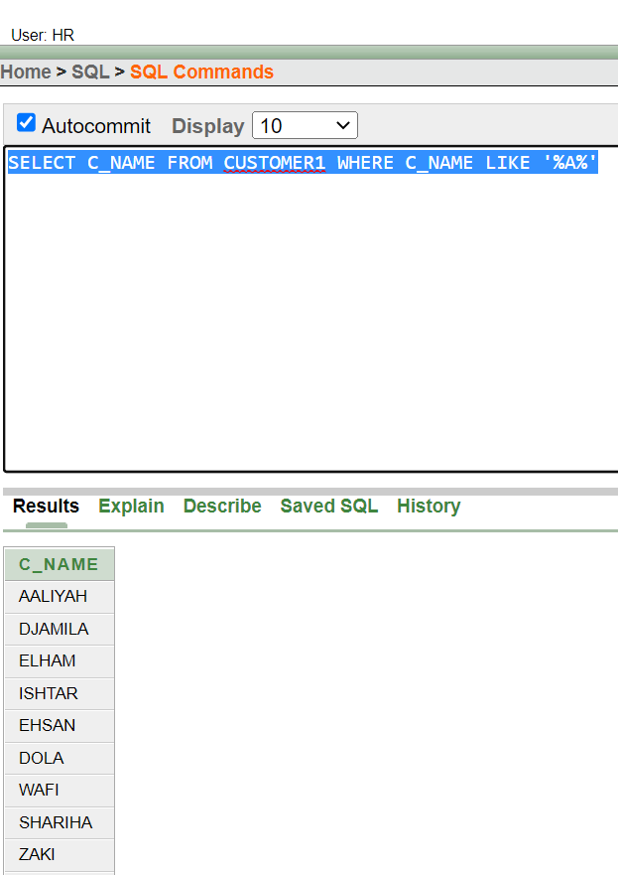

**2.QUESTION:** FIND HOW MANY UNIQUE QUANTITY ARE THERE.

**QUERY:** SELECT DISTINCT(QUANTITY) FROM ORD.

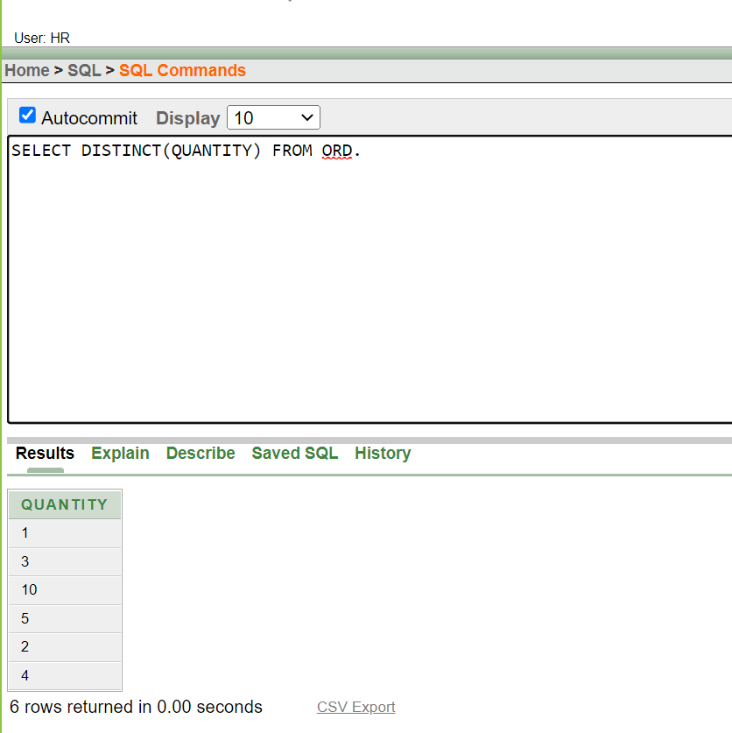

**3.QUESTION:** DISPLAY CUTOMER ID OF ALL CUSTOMER WHO DELIVER 201 AND 202.

**QUERY:** SELECT C_ID FROM CUSTOMER1 WHERE D_ID IN (801,808)

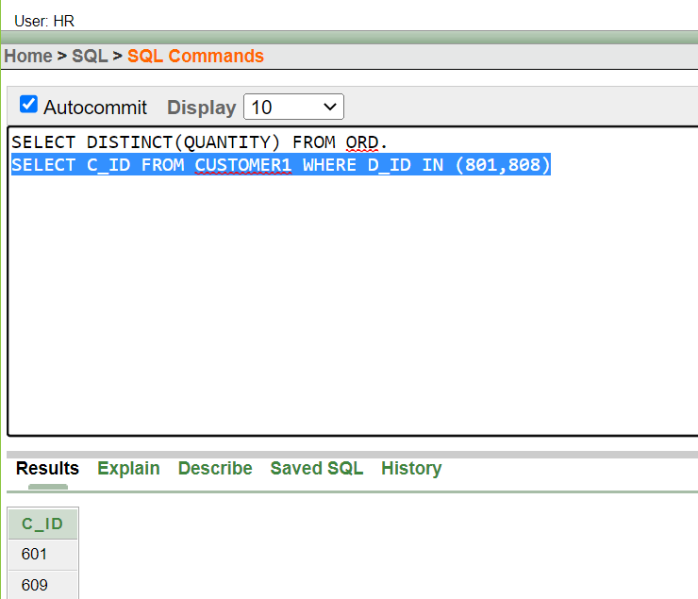

**4.QUESTION:** DISPLAY ORDER ID, TOTAL COST, NO OF ORDER ORDERED BETWEEN 1 DEC-31 DEC.

**QUERY:** SELECT O_ID, TOTAL_COST, NO_OF_ORDER FROM ORD WHERE O_DATE>='01-DEC-12' AND O_DATE<='31-DEC-12'

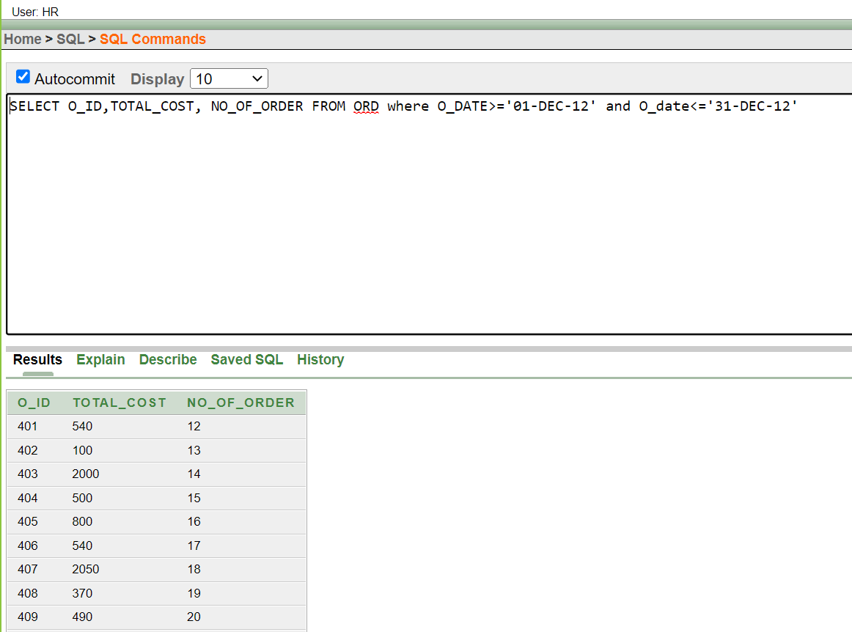

**5.QUESTION:** DISPLAY QUANTITY ID FROM QUANTITY TABLE WHERE THE TOTAL COST IS BETWEEN 1500 TO 3000

**QUERY:** SELECT QNT_ID, TOTAL_COST FROM QNT WHERE TOTAL_COST BETWEEN 1500 AND 3000

